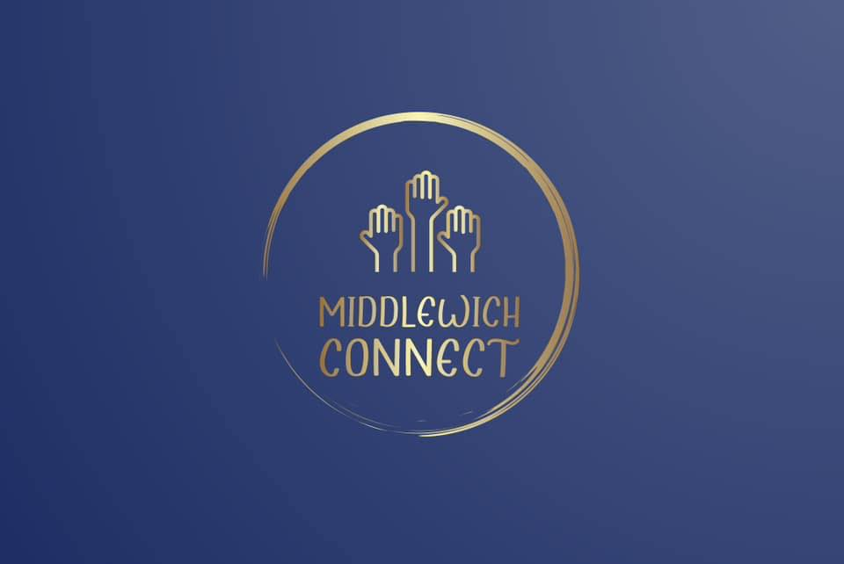
LAUNCH NIGHT!!
18th JULY 2023
7pm-9pm @ The Big Lock,
Webbs Lane, Middlewich
This group is for adults (18years plus) who are neurodivergent (asd/adhd) and / or have learning difficulties or disability.

The aim of this group is to socialise, make friends, psychoeducation, gate keeping to services and offer parent / carer support.

If individuals require 1:1 or 2:1 support then the carer / parent will be required to support this.

All members to complete registration form. The cost will be £10 for registration and £3 per session.

This group will run every other Tuesday 7-9pm. Please keep watching our facebook page for updates to this. Separate access to our area we use from main pub. Disabled toilets easily assessable, wheelchair friendly, access to self-funded refreshments and food. Water will be available for free.

Volunteers are required to support the running of the club – DBS is required please contact us directly if you are able to support.

Email: Middlewichconnect@outlook.com
Or Facebook page Middlewich Connect

