Geography

Curriculum Aims

At St. Mary’s, we are a proud Catholic school, with Christ at the heart of everything we do. We believe that every child is a gift from God, created in his own image and likeness. Our Mission Statement affirms that our aim is that every child reaches their full potential.
Pupils’ learning and development is at the centre of our school’s curriculum; it is broad, balanced and challenging, ensuring pupils develop the skills necessary to succeed in life after primary school. Our welcoming and nurturing environment, based on the Gospel Values, also allows every individual to develop their spiritual, moral, social and cultural growth.
We recognise that our children are the leaders of tomorrow and that we must prepare them to play an active and responsible role in society.

"The study of geography is about more than just memorizing places on a map. It's about understanding the complexity of our world, appreciating the diversity of cultures that exists across continents. And in the end, it's about using all that knowledge to help bridge divides and bring people together."
President Barack Obama

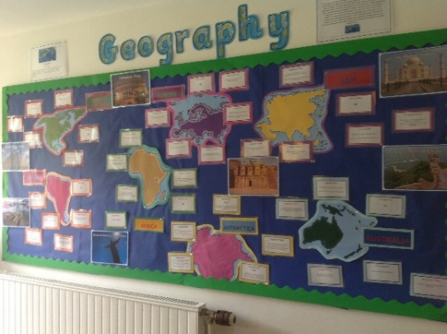

INTENT
Why do we teach what we teach?
The intention of our Geography curriculum is to develop a knowledge of key geographical concepts and facts, through the study of significant geographical topics, which have had a lasting impact on our lives on a global, national and local level. We believe that Geography helps to provoke and answer questions about the natural and human worlds, encouraging children to develop a greater understanding of their world and their place in it.
This means that a knowledge of human and physical features allows our children to become geographically aware of the world around them, while being environmentally sustainable, 21st century citizens, appreciating the changing world.
We intend to deepen our children’s understanding of the world we live in. We want our children to be curious about the changes around us and how things change over time, beyond Middlewich.

We aim to ensure:
All children are happy learners; developing their skills to the best of their ability;
We foster a love of learning, so that children acquire a solid basis for lifelong learning;
We teach children about the love of God and to build their relationship with Him;
We fulfil the requirements of the National Curriculum;
We enable all children to acquire the basic skills in Geography;
We enable creativity, imagination and critical thinking to flourish;
We teach children about the developing world, including how the environment and society have changed over time;
We help children understand Britain’s cultural heritage and the heritage of other cultures
We enable children to be positive citizens in society, empowered to be the leaders of tomorrow, making a difference in the world;
We teach about the importance of a healthy lifestyle and appreciate the importance of mental wellbeing
We enable children to have respect for themselves and high self-esteem, and to be able to live and work co-operatively with others
We use examples of metacognition for retrieval practice which links to our School Improvement Plan.

INCLUSION
St Mary's Catholic Primary School is an inclusive school, which supports and encourages all children to achieve. We are committed to high quality teaching and learning opportunities with Quality First Teaching at the core of curriculum planning. Pupils with special education needs (including gifted and talented children) receive support where appropriate, including differentiated work and small group support from TA's.
IMPLEMENTATION
How do we teach what we teach?
Throughout St Mary’s, Geography is taught progressively and given a high profile within an engaging, broad and balanced curriculum. All teachers use cross-curricular links to provide enhanced teaching points to raise attainment in deciphering, word recognition and comprehension.
Children are exposed to a vocabulary rich environment and teachers provided high quality texts, which allowed pupils to demonstrate good reading skills in other subjects.
In Reception, elements of Geography are delivered to children through the Foundation Stage Curriculum and are incorporated into termly topics.
In both Key Stages, Geography is taught through planning linked to the 2014 Primary National Curriculum. These topics are split according to year groups and can be found on the long-term plans.
We build on prior learning to develop and foster our Investigation, Observation and Application skills:
Year 1 | Year 2
INVESTIGATION  Ge1 Explore and discover the interesting features of the local environment  Ge2 Explore and discover where different foods come from  OBSERVATION  Ge3 Recognise and observe main human and physical features  Ge4 Recognise different types of weather and climate  APPLICATION  Ge5 Express their own views about features of the environment  Ge6 Communicate in different ways using simple geographical information and vocabulary  Ge7 Use simple field work skills  Ge8 Use globes, maps and plans  Ge9 Make simple plans | INVESTIGATION  Ge10 Ask and respond to geographical questions about people, places and environments  Ge11 Investigate, measure and record changes in the weather  OBSERVATION  Ge12 Recognise, observe, describe and record physical and human features  Ge13 Identify links between their locality and other places in the UK and beyond  Ge14 Discuss how weather affects our lives  Ge15 Locate key features on globes, maps and plans  APPLICATION  Ge16 Make simple comparisons between features of different places and say how these features influence life there  Ge17 Use simple compass directions  Ge18 Communicate in different ways using appropriate geographical vocabulary e.g. locational and directional language  Ge19 Use field work and observational skills to carry out simple tasks  Ge20 Use aerial photographs and plan perspectives to identify landmarks and features  Ge21 Make simple maps and plans
Year 3 | Year 4
INVESTIGATION  Ge22 Ask and respond to questions to develop a sense of place  Ge23 Collect and record evidence and begin to offer explanations  Ge24 Investigate key aspects of human and physical geography  Ge25 Explore places with different climate zones  OBSERVATION  Ge26 Identify where significant places are located in the UK, Europe and the wider world  Ge27 Identify similarities and differences between places and environments and understand how they are linked  Ge28 Identify how the ways in which people live sometimes have consequences for the environment  APPLICATION  Ge29 Use appropriate geographical vocabulary to communicate their findings  Ge30 Collect and analyse a range of data from simple fieldwork experiences  Ge31 Use atlases, globes, maps and plans at a range of scales and draw simple maps and plans  Ge32 Use ICT to help in geographical investigations | INVESTIGATION  Ge33 Ask and respond to geographical questions and offer their own ideas  Ge34 Explore places with different climate zones and compare and describe how climate affects living things  OBSERVATION  Ge35 Identify where significant places are located in the UK, Europe and the wider world  Ge36 Observe and appreciate the relationship between the physical, built and economic and social environments  Ge37 Identify how different ways in which people live around the world sometimes have consequences for the environment and the lives of others from local to global scales  APPLICATION  Ge38 Use appropriate geographical vocabulary in communicating findings  Ge39 Employ a wider range of field work techniques and instruments to collect and analyse a range of data  Ge40 Describe, compare and offer reasons for their views  Ge41 Interpret information from different types of atlases, globes, maps and plans at a range of scales  Ge42 Use secondary sources of information and ICT as part of investigations
Year 5 | Year 6
INVESTIGATION  Ge43 Ask suitable geographical questions leading to investigation  Ge44 Investigate ways in which environments can be improved  Ge45 Investigate using an increasing range of primary and secondary sources of information  OBSERVATION  Ge46 Analyse evidence and draw conclusions  Ge47 Identify a range of geographical processes that cause change in the physical and human world in different places  APPLICATION  Ge48 Use appropriate geographical vocabulary to communicate in a variety of ways  Ge49 Use atlases, globes, maps and digital /computer mapping at a range of scales  Ge50 Draw plans and maps at a variety of scales  Ge51 Use the eight points of the compass  Ge52 Use appropriate field work techniques and instruments to observe, measure and record human and physical features in the local area | INVESTIGATION  Ge53 Ask questions, explore, describe and explain geographical patterns, similarities, differences and physical and human processes  Ge54 Collect and record evidence independently  Ge55 Investigate ways in which environments can be managed sustainably and why this is important now and in the future  OBSERVATION  Ge56 Identify and explain different views that people, including themselves, hold about topical geographical issues  Ge57 Observe & explain how human patterns are influenced by human & physical features  APPLICATION  Ge58 Use and select primary and secondary sources of information and evidence, suggest conclusions and present findings in a variety of ways  Ge59 Use atlases, globes, maps and digital /computer mapping at a range of scales, including four and six-figure grid references  Ge60 Draw plans and maps at a variety of scales  Ge61 Use and select appropriate ICT to help in geographical investigations  Ge62 Use symbols and keys when sketching maps, plans and graphs

Children will therefore have the opportunity to become increasingly proficient and confident at:
- Using age-appropriate, accurate knowledge of physical and human characteristics of a wide range of globally significant places
- Using this knowledge to understand the actions of important geographical processes
- Understanding that these processes give rise to physical and human geographical features
- Using geographical vocabulary which is appropriate and accurate
- Collecting, analysing and presenting a range of data, gathered through fieldwork
- Using and interpreting a wide range of sources of geographical information, including maps, diagrams, globes and aerial photographs
- Communicating geographical information in a variety of ways
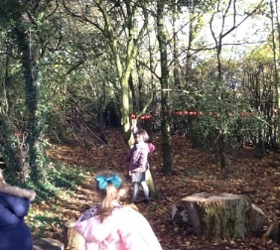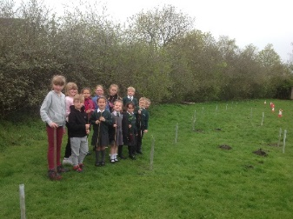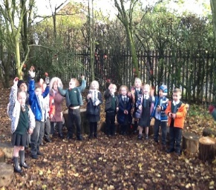

IMPACT
How do we measure what we teach?
At St Mary’s, we keep abreast of the progress and attainment of all children throughout their learning journey. We do this in a variety of ways:
- We provide children with knowledge organisers for all topics taught.
- We use interactive Kahoot quizzes based on different elements of topics.
- We ensure children apply their skills including: mapping, fieldwork, enquiry and investigation communication and use of ICT/technology.
- We ensure learning is distributed over multiple sessions rather than being massed into one chunk. We do this through our training in Spaced Retrieval Practice.
- We use and are trained in using LYFTA Global Learning resources which focusses on nurture, resilience, empathy and global citizenship.
- We focus on key vocabulary for all topics which is highly visible throughout our school.
- We provide summative assessments, such as end of topic tasks, quizzes, essays and knowledge organisers.
- We conduct pupil voice interviews to assess children’s understanding and views on different topics.
- Final judgements are provided at the end of each term. These are either judged as:
Emerging, Expected or Exceeding.
- Staff meeting time provided for CPD opportunities and to moderate pieces of work across key stages.
"It is in your hands to create a better world for all who live in it.”
Nelson Mandela

