ST MARY’S CATHOLIC PRIMARY LONG-TERM OVERVIEW 2024-2025 – YEAR 1

Y1 |  | Autumn 1 |  | Autumn 2 |  | Spring 1 |  | Spring 2 | Summer 1 |  |  | Summer 2
ENGLISH
CORE TEXT | 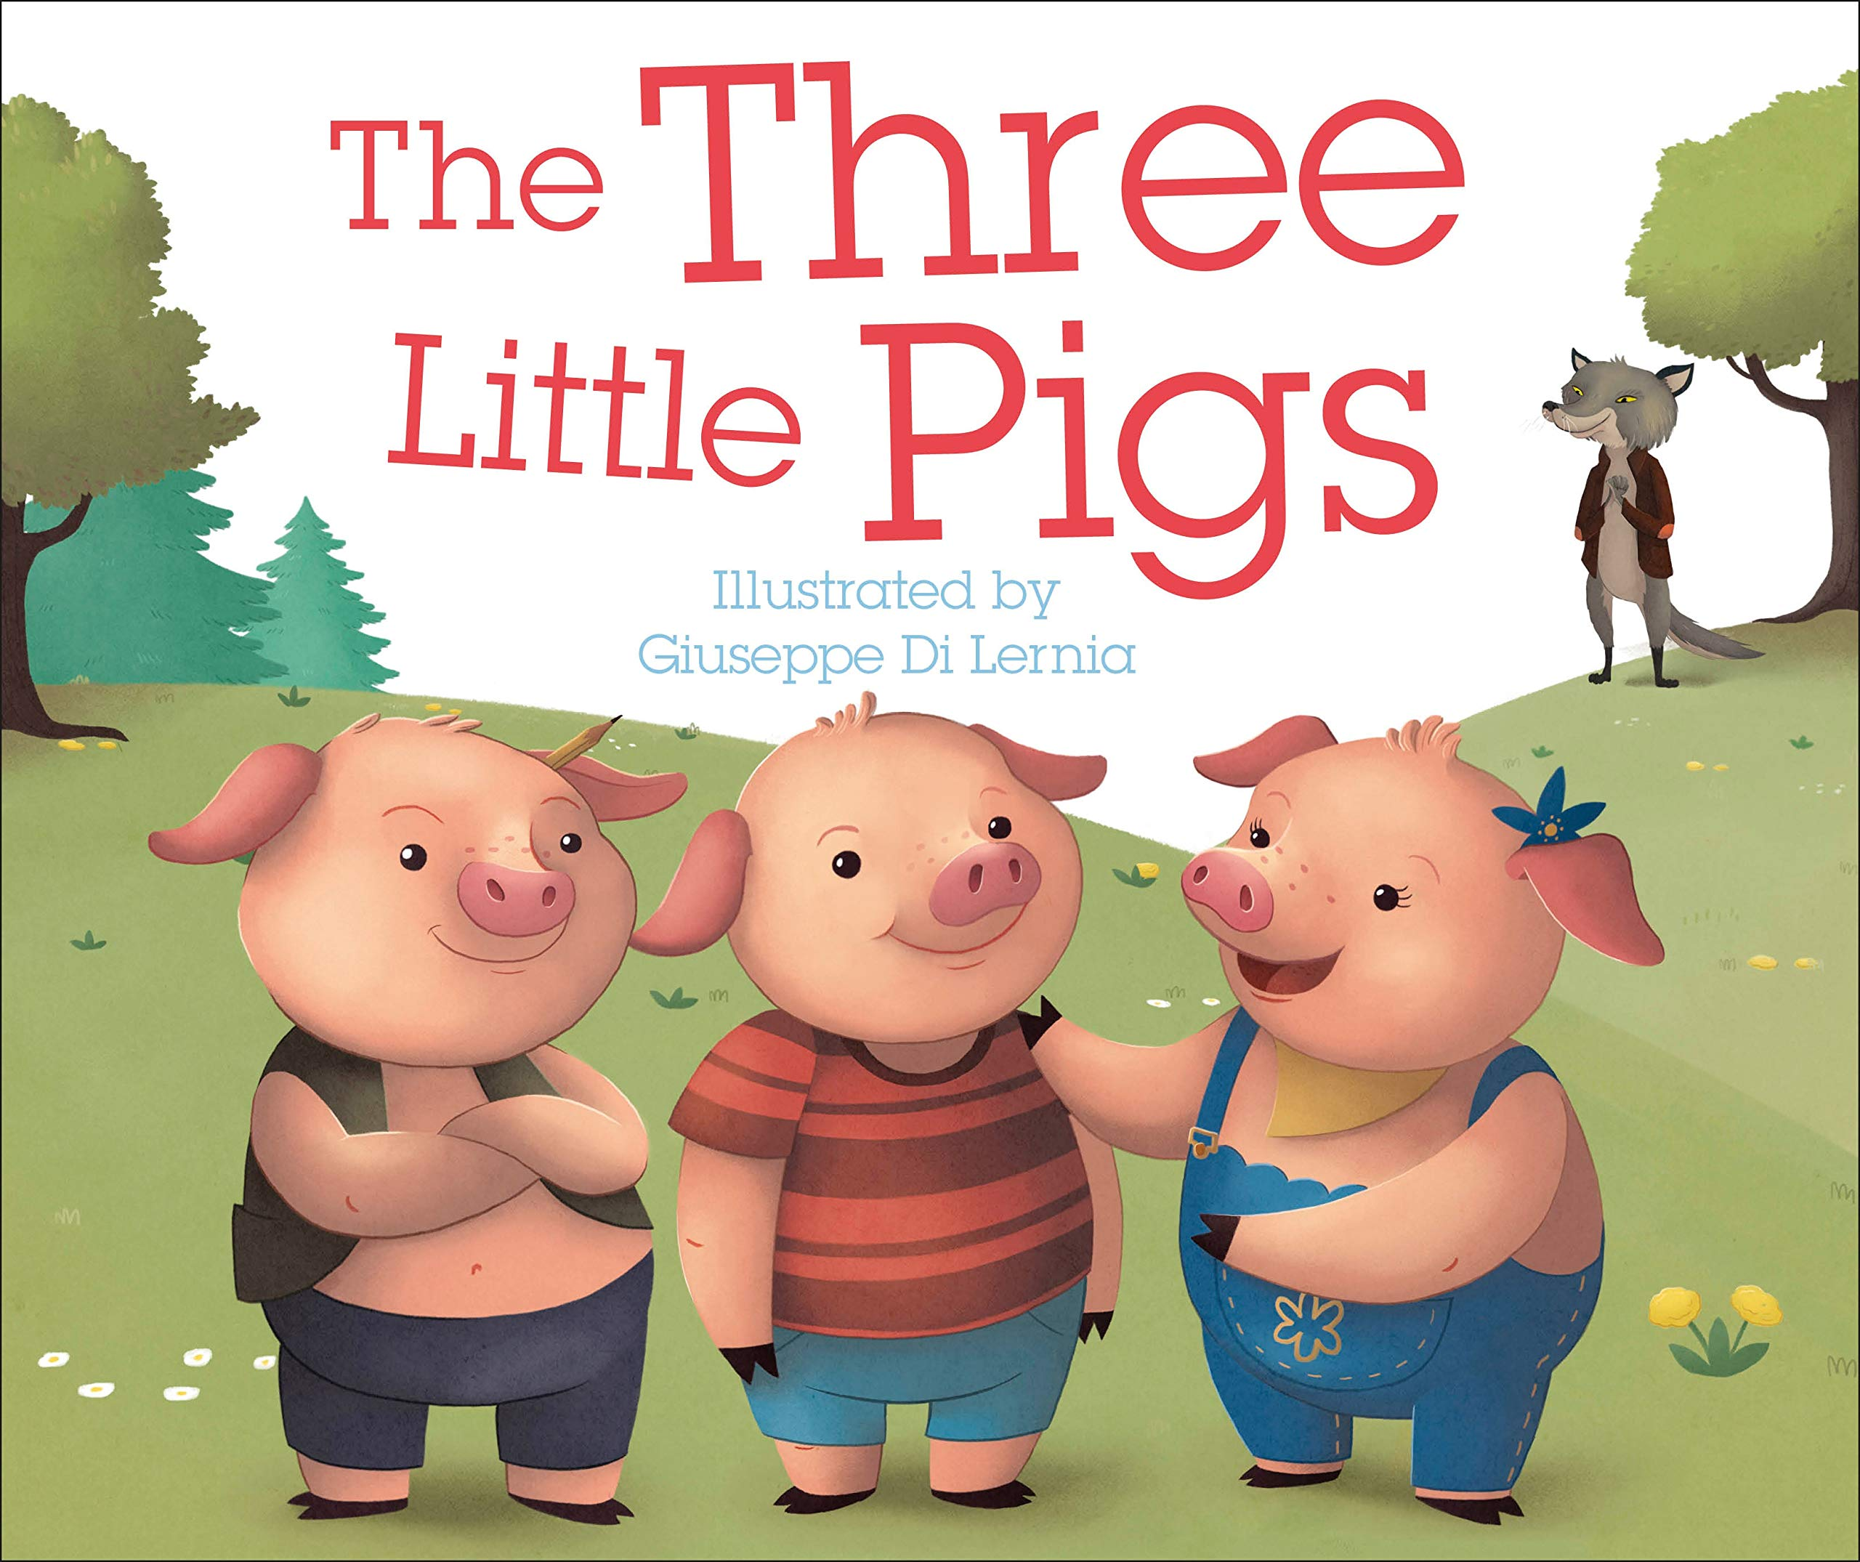 |  | 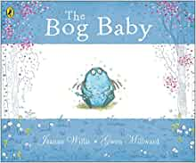 |  | 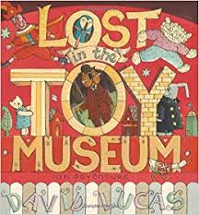 |  | 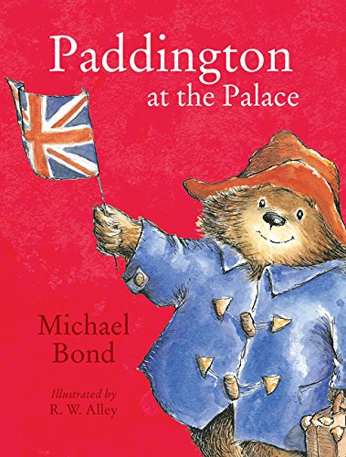 |  |  | 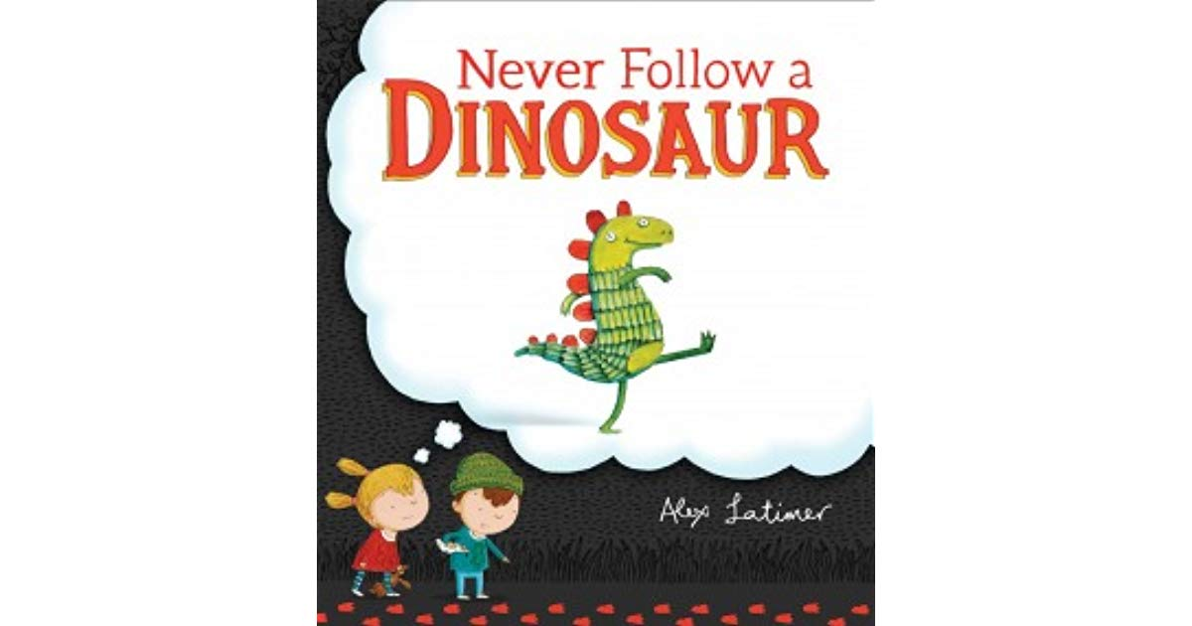 | 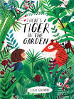
ENGLISH UNITS | The Three Little Pigs  Narrative – traditional tale  Non-fiction – instructions – how to build a house.  Poetry – linked to topic or to Harvest/Autumn |  | Bog Baby  Narrative Adventure Story in familiar setting  Non-fiction – recount |  | Lost in the Toy Museum  Narrative – linked to History topic  Non-fiction – Non-chronological report about toys. |  | Paddington at the Palace  Narrative – story linked to geography topic  Non-fiction – recount – Paddington’s visit to school.  Poetry – linked to topic or to Spring |  |  | Never Follow A Dinosaur  Narrative – story linked to Science topic  Non-fiction – instructions - how to catch a dinosaur. | There’s a Tiger in the Garden  Narrative - fantasy story  Non-fiction – Non-chronological report about tigers.  Poetry – linked to topic or to Summer
MATHS
Maths | Number and place value: numbers to 10  Part whole within 10  Addition and Subtraction – addition and subtraction within 10 |  | Addition and Subtraction – addition and subtraction within 10  Properties of shape – 2D and 3D shapes  Number and place value: numbers to 20 |  | Addition and subtraction: addition within 20  Addition and subtraction: subtraction within 20 |  | Numbers and place value: numbers to 50  Measurement: introducing length and height  Measurement: introducing weight and volume |  |  | Multiplication and Division: Multiplication  Multiplication and Division: Division  Fractions – halves and quarters | Geometry: position and direction  Numbers and place value: numbers to 100  Measurement: time  Measurement: money
RE
RE | Creation and Covenant |  | Prophecy and Promise |  | Galilee to Jerusalem |  | From Desert to Garden |  |  | To the Ends of the Earth | Dialogue and Encounter
Science
Science | Seasonal Changes |  | Everyday Materials |  | Animals including humans (focusing on animals and grouping) |  | Animals including humans (focusing on animals and grouping) |  |  | Plants | Plants
Computing
Comp | Online Safety and Exploring Purple Mash |  | Grouping and Sorting  Pictograms |  | Lego Builders  Maze Explorers |  | Animated Story Books |  |  | Coding | Spreadsheets  Technology Outside School
History
History | How am I making history? |  | How am I making history? |  | How have toys changed? |  | How have toys changed? |  |  | How have explorers changed the world? | How have explorers changed the world?
Geography
Geog | What is it like here? |  | What is it like here? |  | What is the weather like in the UK? |  | What is the weather like in the UK? |  |  | What is it like to live in Shanghai? | What is it like to live in Shanghai?
Art and Design
Art | Drawing: Make your mark |  | Drawing: Make your mark |  | Painting and mixed media: Colour splash |  | Painting and mixed media: Colour splash |  |  | Craft and design: Woven wonders | Craft and design: Woven wonders
Design and Technology
DT | Textiles: Puppets |  | Textiles: Puppets |  | Mechanisms: Wheels and Axels |  | Mechanisms: Wheels and Axels |  |  | Structures: Constructing a windmill | Food: Smoothies
Music
Music | Pulse and rhythm (Theme: All about me) |  | Timbre and rhythmic patterns (Theme: Fairy tales) |  | Musical vocabulary (Theme: Under the sea) |  | Pitch and tempo (Theme: Superheroes) |  |  | Classical music, dynamics and tempo (Theme: Animals) | Vocal and body sounds: (Theme: By the sea)
PE
PE | Ball Skills (throwing and Catching)  Dance (Seasons) |  | S.A.Q  Dance - Seasons |  | Ball Skills (handling coordination, running)  Gymnastics – Under the sea |  | Striking and Fielding  Gymnastics – Under the sea |  |  | Athletics  Tri Golf( to incorporate balance and coordination) | Athletics  Tri Golf (to incorporate balance and coordination)
MFL
MFL | Oui / non.  Greetings.  Answer the register in French.  Je m’appelle… |  | Say how they are and ask others.  Count to 10. |  | Merci / S’il vous plait.  Numbers out of sequence.  Verbs of opinions. |  | Classroom instructions.  Bon appétit! Monsieur Lapin |  |  | Days of the week.  Colours. | Aaaagh une araignée!  Consolidation and revision.
PSHE
PSHE |  |  | - Let the children come  - God loves you  - Special people |  | - Treat others well and say sorry  - Being safe  - Good and bad secrets |  | - Physical contact  - Harmful substances |  |  | - Can you help me? Part 1 &2  - Three in One | - Who is my neighbour?  - The communities we live in

