ST MARY’S CATHOLIC PRIMARY LONG TERM OVERVIEW 2025-2026 – YEAR 3

Y3 |  | Autumn 1 |  | Autumn 2 | Spring 1 |  | Spring 2 | Summer 1 |  |  | Summer 2
Trips |  | Tatton Park 17th October |  |  |  |  | Middlewich local walk combining the Roman history | Petty Pool 23/24th April |  |  | Trentham Gardens
ENGLISH
CORE TEXT | 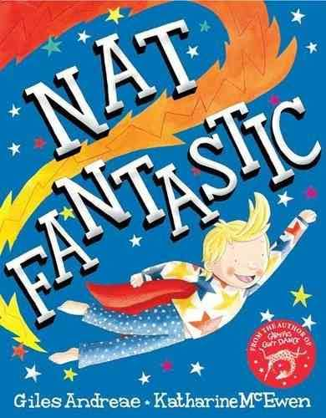 |  | 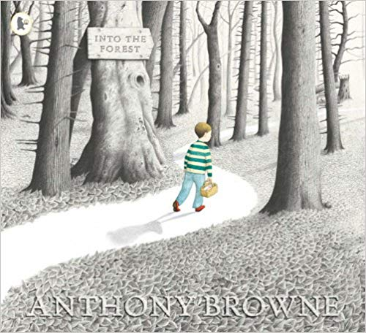 |  | 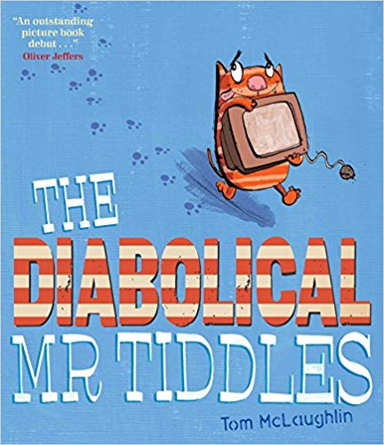 | 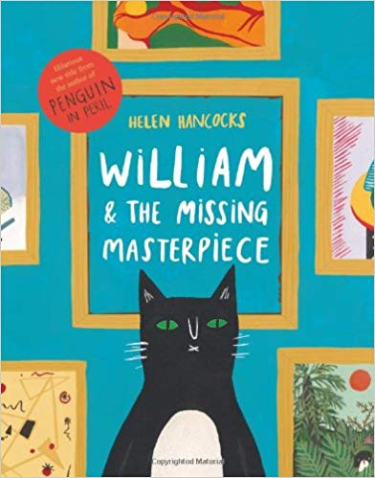 |  |  | 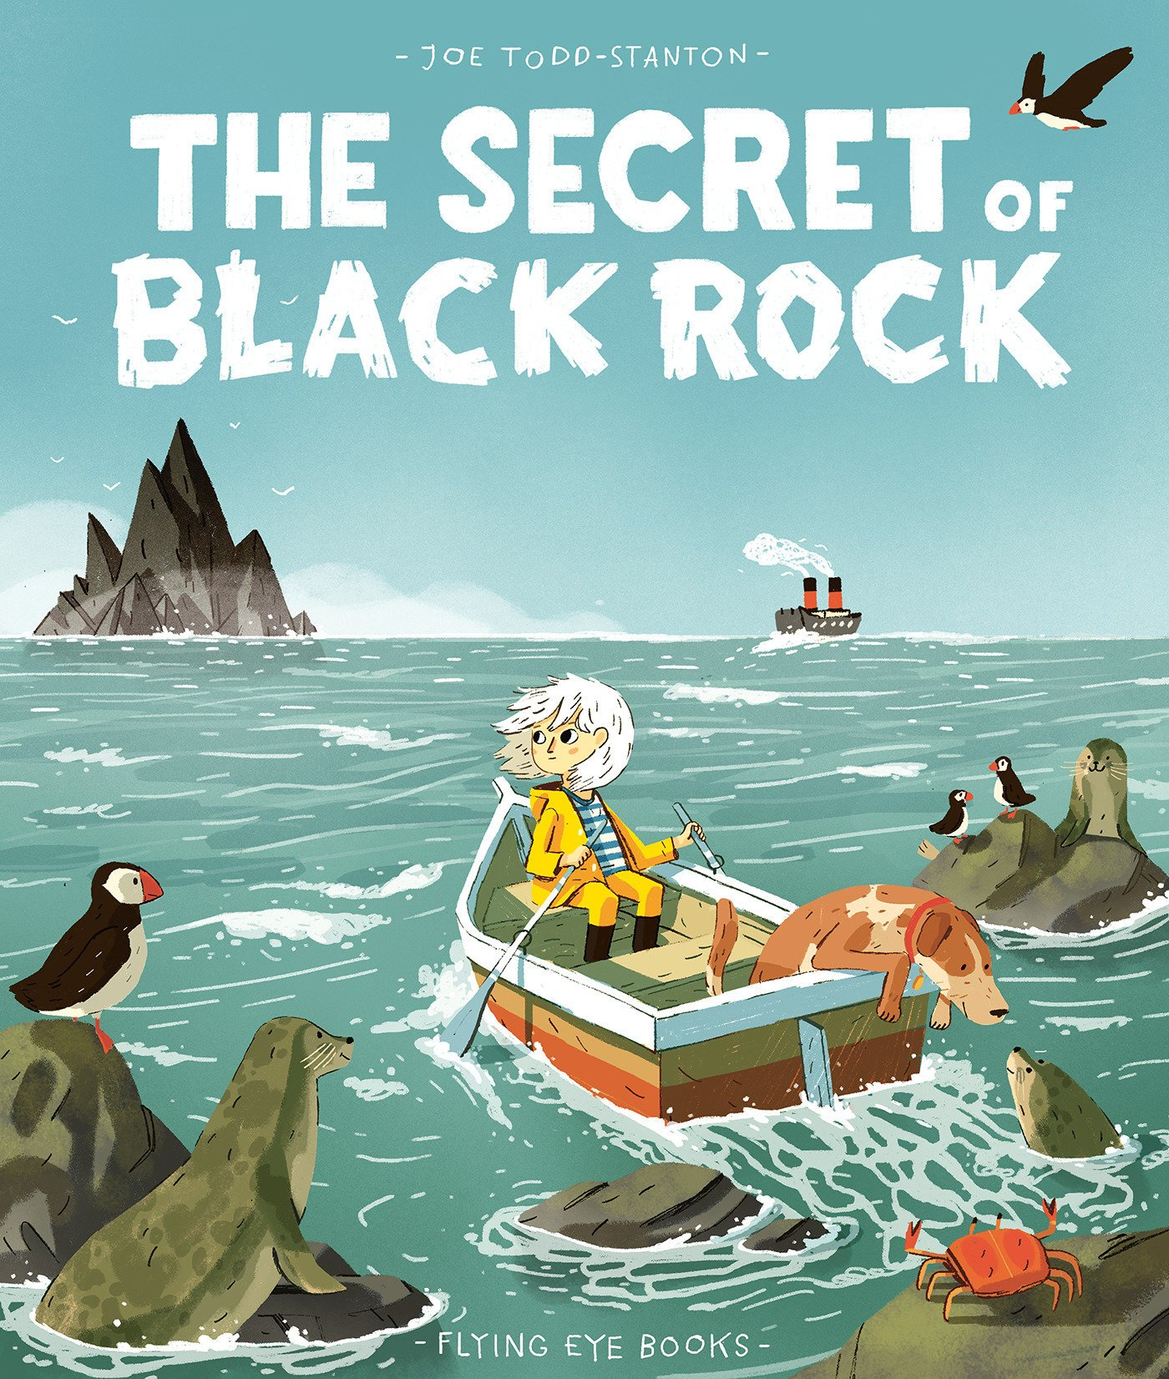 | 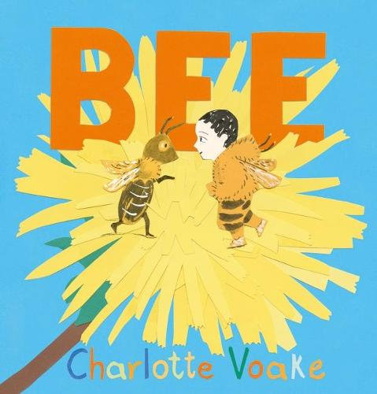
ENGLISH UNITS | Nat Fantastic  by Giles Andreae  Adventure story in familiar setting  Non chronological report  Class Read  The Hodgeheg  (Dick King Smith)  Short Novel |  | Into the Forest  by Anthony Browne  Traditional Tale  Instructions  Class Read  The Proudest Blue and other picture books  Diversity |  | The Diabolical Mr Tiddles  by Tom McLaughlin  Narrative (PSHE focus)  Newspaper Report  Class Read  The Diary of a Killer Cat  (Anne Frank)  Short Novel | William and the missing masterpiece  by Helen Hancocks  Narrative – Mystery  Recount – Diary entry  Spring Poems  Class Read  Class choice |  |  | The Secret of the Black Rock  by Joe Todd-Stanton  Narrative – Fantasy  Non chronological report  Class Read  Interview with a Shark  (Andy Seed)  Non-Fiction | Bee  by Charlotte Voake  Narrative (Topic)  Persuasive advert/poster  Class Read  The Iron Man  (Ted Hughes)  Short Novel
MATHS
Maths | Number Unit 1  Number and Place Value within 1,000  (11 lessons)  Number Unit 2  Addition and subtraction 1  (10 lessons) |  | Number Unit 3  Addition and subtraction 2  (9 days)  Number Unit 4  Multiplication and division 1  (15 lessons) |  | Number Unit 5  Multiplication and division 2  (14 lessons)  Measurement Unit 6  Money  (5 lessons)  Statistics Unit 7  Statistics  (5 lessons) | Measurement Unit 8  Length  (11 lessons)  Number Unit 9  Fractions 1  (11 lessons) |  |  | Number Unit 10  Fractions 2  (9 lessons)  Measurement Unit 11  Time  (11 lessons) | Geometry Unit 12  Angles and properties of shapes  (9 lessons)  Measurement Unit 13  Mass  (6 lessons)
RE
RE | Creation & Covenant |  | Prophecy & Promise |  | Galilee to Jerusalem | Desert to Garden |  |  | Ends of the Earth | Dialogue & Encounter
Science
Science | Rocks, fossils and soil |  | Rocks, fossils and soil  Forces and magnets – Friction, magnetic forces, attract or repel |  | Forces and magnets – Friction, magnetic forces, attract or repel  Animals including humans –  Nutrition, skeletons and muscles | Animals including humans – Nutrition, skeletons and muscles  Light –  to see things, light reflected, sun dangerous, shadows  Plants |  |  | Light –  to see things, light reflected, sun dangerous, shadows  Plants | Plants
Computing
Computing | Online Safety & Computing Systems & networks – connecting computers |  | Creating media – stop frame animation |  | Programming A - Sequencing sounds | Data & Information – Branching Databases |  |  | Creating media – Desktop publishing | Programming B – Events and actions in programs
History
History | Stone Age to Iron Age |  | Stone Age to Iron Age |  | Romans | Romans |  |  | Ancient Egypt including ancient civilisations | Ancient Egypt including ancient civilisations
Geography
Geography | Why do people live near volcanoes? |  | Why do people live near volcanoes? |  | Are all settlements the same? | Are all settlements the same? |  |  | Who lives in Antarctica? | Who lives in Antarctica?
Art and Design
Art | Painting and mixing media: Prehistoric painting |  | Painting and mixing media: Prehistoric painting |  | Drawing: Growing artists | Drawing: Growing artists |  |  | Craft and Design: Ancient Egyptian Scrolls | Craft and Design: Ancient Egyptian Scrolls
Design and Technology
DT | Mechanical systems: Pneumatic toys |  | Mechanical systems: Pneumatic toys |  | Structures: Constructing a castle | Structures: Constructing a castle |  |  | Food: Eating seasonally | Food: Eating seasonally
Music
Music | Creating compositions in response to an animation (Theme: Mountains) |  | Jazz |  | Pentatonic melodies and composition (Theme: Chinese New Year) | Developing singing technique (Theme: the Vikings) |  |  | Ballads | Traditional instruments and improvisation (Theme: India)
PE
PE | Football  Dance |  | Netball  Strength and Flexibility |  | Hockey  Dodgeball | Tri golf  Gymnastics – movement |  |  | Athletics/Badminton  Swimming | Rounders/Circuits(H&F)  Swimming
MFL
MFL | Basic questions about themselves |  | Classroom items |  | Identify the gender of a noun | Bilingual dictionaries  Family  Pets |  |  | Plural of nouns  Numbers to 39  Sentences with il y a | Months  Dates  Birthdays
PSHE
PSHE | Get up!  The Sacraments |  | Jesus, my friend  Friends, family and others |  | When things feel bad  Sharing online | Chatting online  Safe in my body |  |  | Drugs, alcohol and tobacco  First aid heroes | A community in love  What is church?  How do I love others?

