Year 2 Spellings – Autumn 1

Week 1 (to be tested 19/9/25)  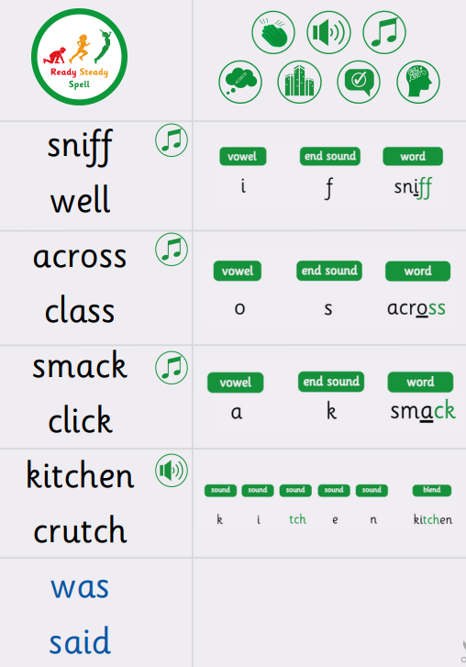 | Week 2 (to be tested 26/9/25)  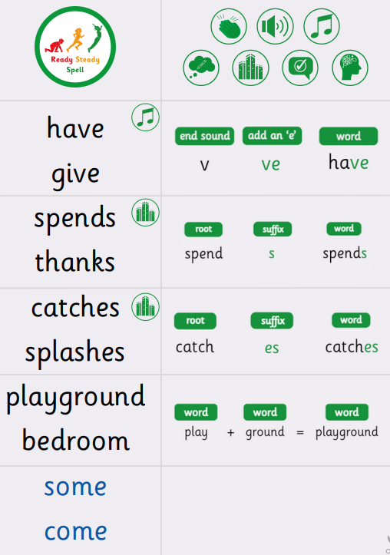
Week 3 (to be tested 3/10/25)  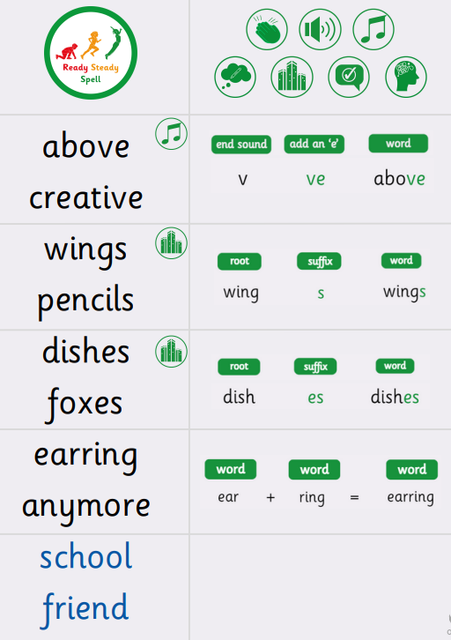 | Week 4 (to be tested 10/10/25)  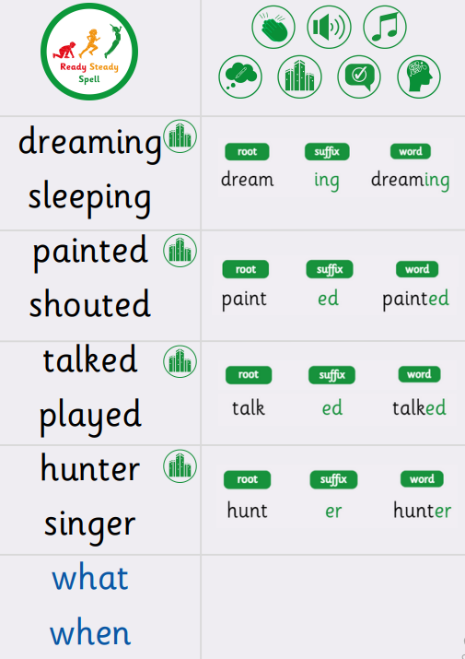
Week 5 (to be tested 17/10/25)  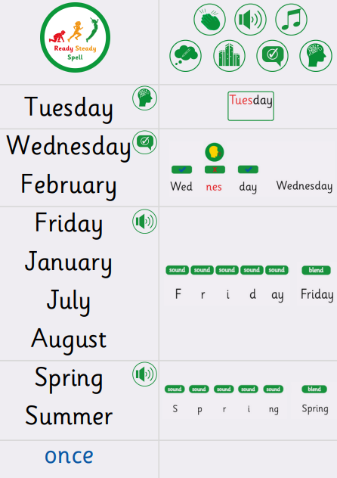 | Week 6 (to be tested 24/10/25)  All spellings from Weeks 1-5!  Try to focus on the ones you found more difficult or didn’t get correct.

