Year 5 Spellings – Autumn 2

Week 1 (to be tested 14/11/25)  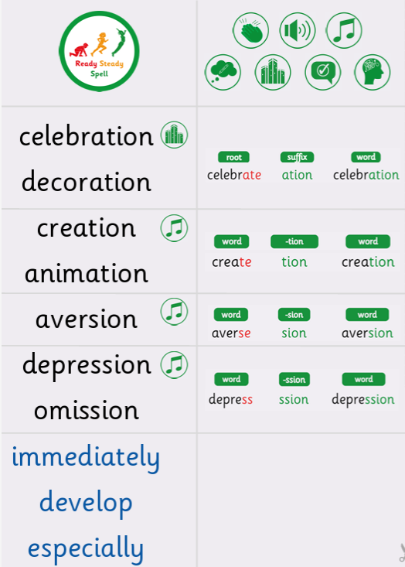 | Week 2 (to be tested 21/11/25)  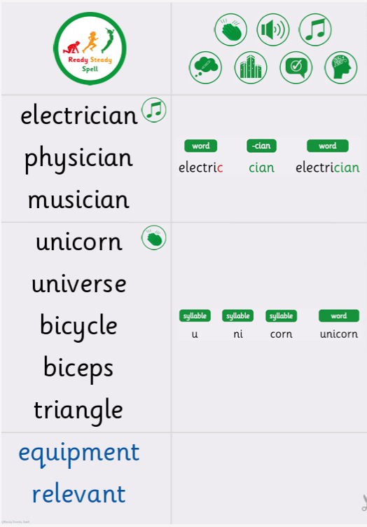
Week 3 (to be tested 28/11/25)  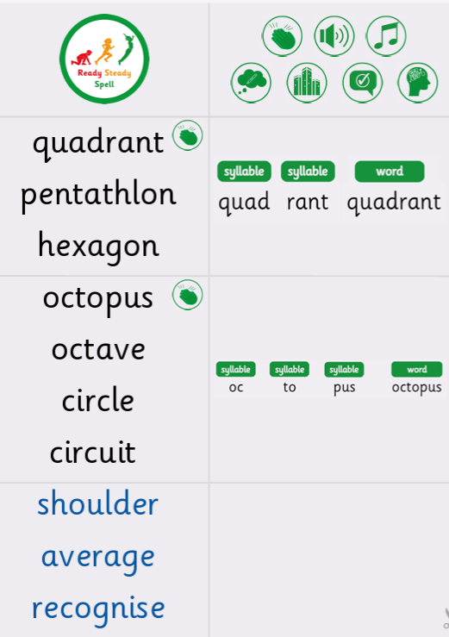 | Week 4 (to be tested 05/12/25)  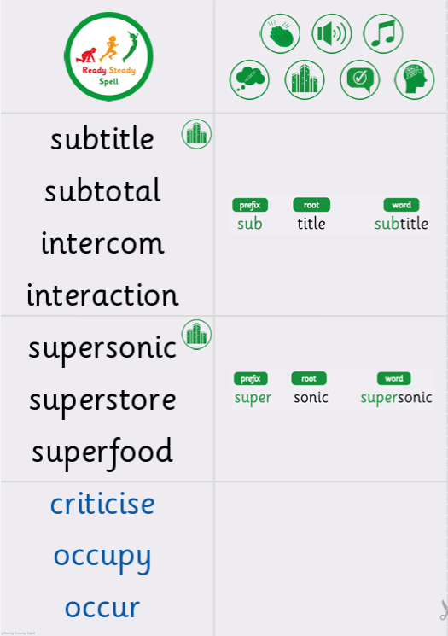
Week 5 (to be tested 12/12/25)  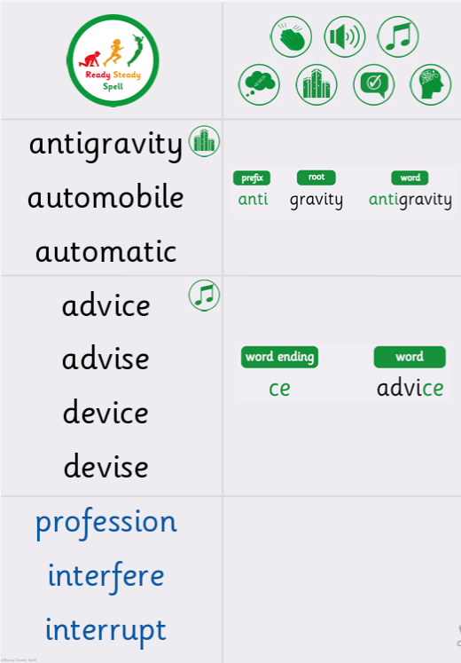 | Week 6 (to be tested 19/12/25)  All spellings from Weeks 1-5!  Try to focus on the ones you found more difficult or didn’t get correct.

