Year 4 Spellings – Spring 1

Week 1 (to be tested 9/1/26)  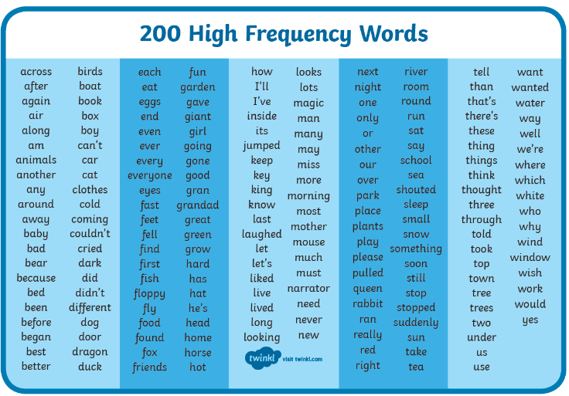  Spellings will be taken from the 200 High Frequency Word List, at random. | Week 2 (to be tested 16/1/26)  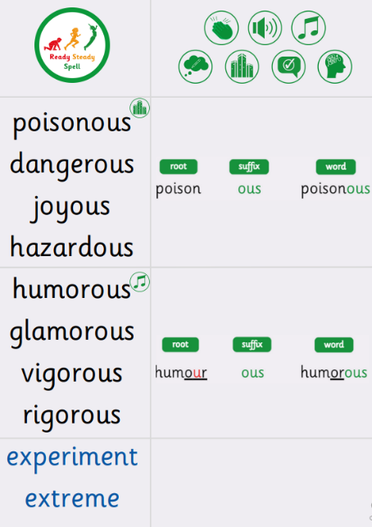
Week 3 (to be tested 23/1/26)  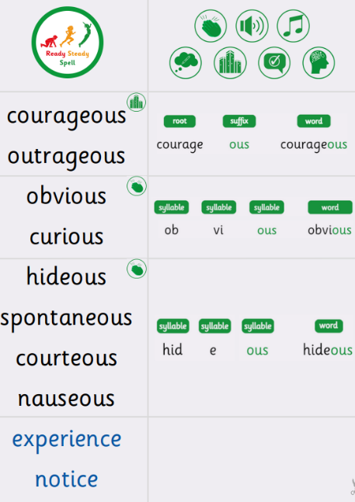 | Week 4 (to be tested 30/1/26)  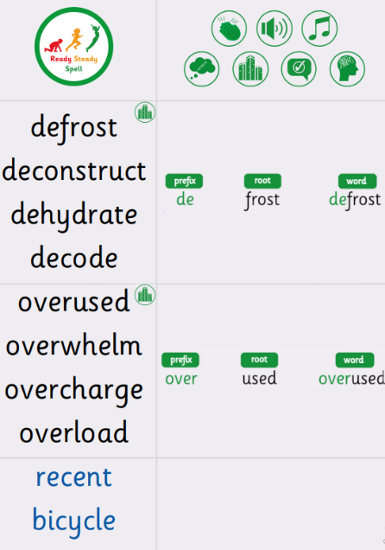
Week 5 (to be tested 6/2/26)  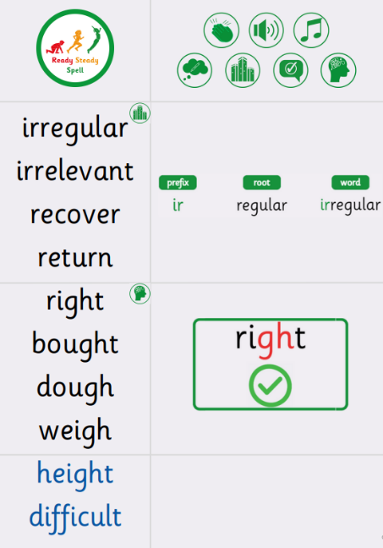 | Week 6 (to be tested 13/2/26)  All spellings from Weeks 2-5!  Try to focus on the ones you found more difficult or didn’t get correct.

