ST MARY’S CATHOLIC PRIMARY LONG TERM OVERVIEW 2025-2026 – YEAR 5

Y5 | Autumn 1 | Autumn 2 | Spring 1 | Spring 2 | Summer 1 |  |  | Summer 2
RE
RE |   Creation & Covenant |   Prophecy & Promise |   Galilee to Jerusalem |   Desert to Garden |   To the Ends of the Earth |  |  |   Dialogue & Encounter
ENGLISH
CORE TEXT | 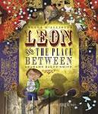 | 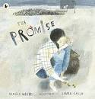 | 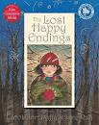 | 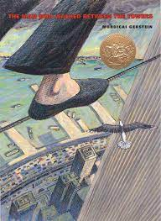 |  | 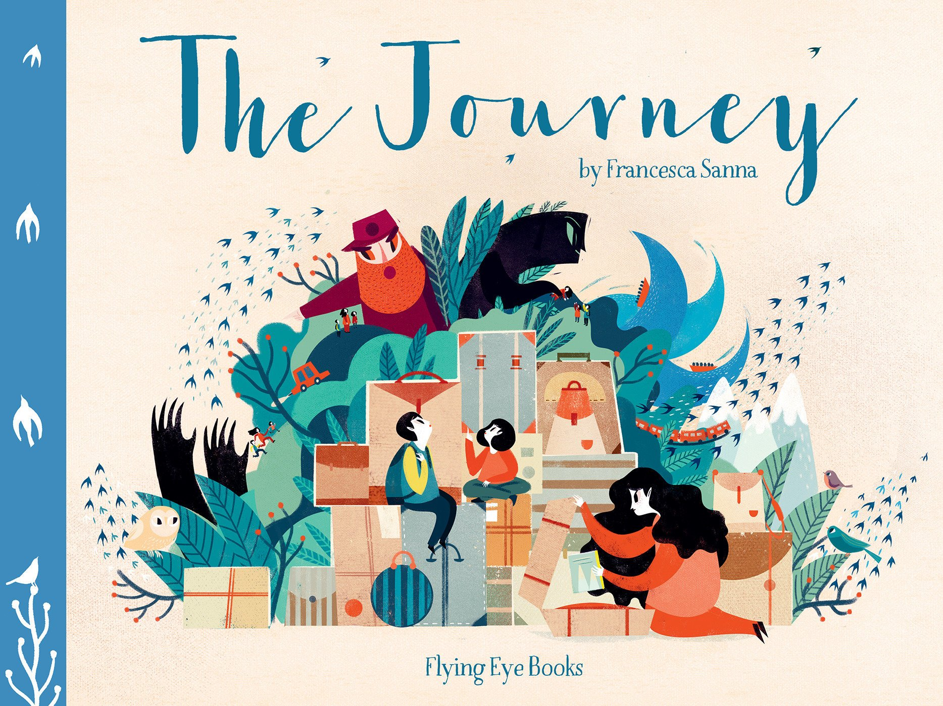 | 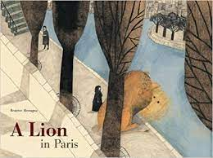
ENGLISH UNITS | Leon and the Place Between  by Angela McAllister  Adventure Story  Instructions | The Promise  by Nicola Davies  Narrative with a PSHE Focus  Non-Chronological Report  Christmas Poetry | The Lost Happy Endings  by Carol Ann Duffy  Traditional Tale  Persuasive Letter | The Man Who Walked Between The Towers  by Mordicai Gerstein  Descriptive Narrative  Newspaper Report |  | The Journey  by Francesca Sanna  Viewpoint Narrative  Explanation (linked to Geography) | A Lion in Paris  By Beatrice Alemagna  Narrative with a Familiar Setting  Balanced Argument
CLASS READ | Harry Potter and the Philosopher’s Stone  (JK Rowling)  Complexity of Plot | An Eagle in the Snow  (Michael Morpurgo)  Non-Linear Sequence | Tom’s Midnight Garden  (Philippa Pearce)  Archaic Text | The Fastest Boy in the World  (Elizabeth Laird)  Diverse Text |  | Jabberwocky  (Lewis Carroll)  Resistant Text | The 1000 Year Old Boy  (Ross Welford)  Complexity of Narrator
MATHS
MATHS | Place Value within 100,000 (Unit 1)  Place Value within 1,000,000 (Unit 2)  Addition and Subtraction (Unit 3) | Multiplication and Division (Unit 5)  Fractions (Units 8) | Multiplication and Division (Unit 7)  Graphs and Tables (Unit 4)  Area and Perimeter  (Unit 6) | Fractions (Units 9 and 10)  Decimals and Percentages (Unit 11) |  | Decimals (Unit 12)  Measure – Converting Units (Unit 16) | Properties of shapes  (Unit 13/14)  Position and Direction (Unit 15)  Measure – Volume and Capacity (Unit 17)

Science
Science | Properties and Changes of Materials | Properties and Changes of Materials | Living things and their habitats | Animals Including humans |  | Forces | Earth and Space
Computing
Computing | Online Safety  Computing systems and networks – systems and searching | Creating media – video production | Programming A – selection in physical computing | Data and information – flat-file databases |  | Creating media – introduction to vector graphics | Programming B – selection in quizzes
History
History | How did the Mayan civilisation compare to the Anglo-Saxons? | How did the Mayan civilisation compare to the Anglo-Saxons? | What was life like in  Tudor England? | What was life like in Tudor England? |  | What did the Greeks ever do for us? | What did the Greeks ever do for us?
Geography
Geography | Would you like to live in the desert? | Would you like to live in the desert? | Why do oceans matter? | Why do oceans matter? |  | Why does population change? | Why does population change??
Art and Design
Art | Drawing – Depth, emotion and movement | Drawing – Depth, emotion and movement | Painting and mixed media: Portraits | Painting and mixed media: Portraits |  | Sculpture and 3D: Interactive installation | Sculpture and 3D: Interactive installation
Design and Technology
DT | Textiles –  Stuffed Toys | Textiles –  Stuffed Toys | Food –  What could be healthier? | Food –  What could be healthier? |  | Digital World – Monitoring Devices | Digital World – Monitoring Devices
Music
Music | Wider Ops | Wider Ops | Wider Ops | Looping and Remixing |  | Composition to represent the Festival of Colour | Musical Theatre
PE
PE | Football  Swimming | Basketball/  Sports Hall Athletics  Swimming | Hockey  Gymnastics | Cricket  Dodgeball |  | Tag Rugby  Tennis | Rounders  Athletics
MFL
MFL | Numbers to 100  Numbers in the thousands | Prices  Planets | Adjectival agreement  Descriptive sentences (to be + adjectives) | Body parts  Description of a ‘strange animal’ | Sports  Je joue vs je fais |  |  | Opinion sentences  Negative sentences

PSHE
PSHE | Online Safety  Calming the storm  Is God calling you?  Ten Ten  Picture News  British Values | Under pressure  Do you want a piece of cake?  Self-talk  Ten Ten  Picture News  British Values | Sharing isn’t always caring  Cyberbullying  Ten Ten  Picture News  British Values | Types of abuse  Impacted lifestyles  Ten Ten  Picture News  British Values | Making good choices  Giving assistance  Ten Ten  Picture News  British Values | The Holy Trinity  Catholic Social Teaching  Reaching out  Ten Ten  Picture News  British Values

