Year 4 Spellings – Spring 2

Week 1 (to be tested 27/2/26)  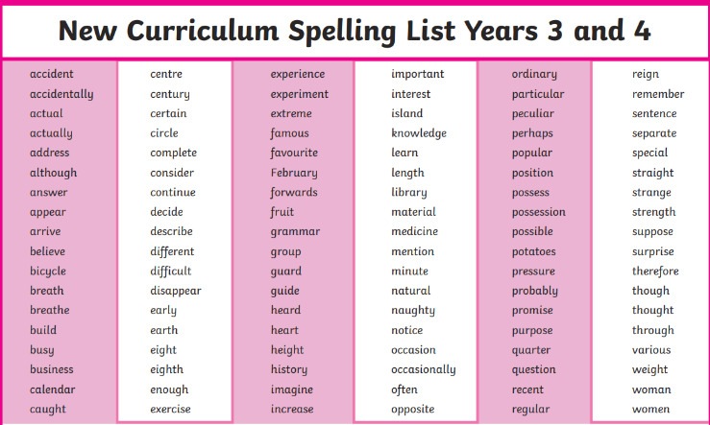  Spellings will be taken from the Year 3/4 National Curriculum Word List, at random. | Week 2 (to be tested 6/3/26)  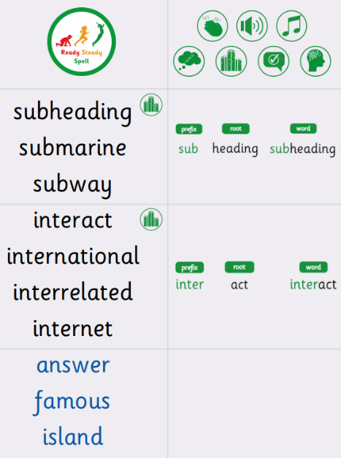
Week 3 (to be tested 13/3/26)  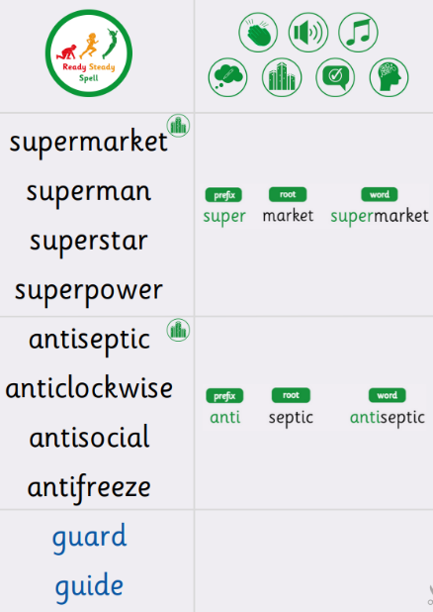 | Week 4 (to be tested 20/3/26)  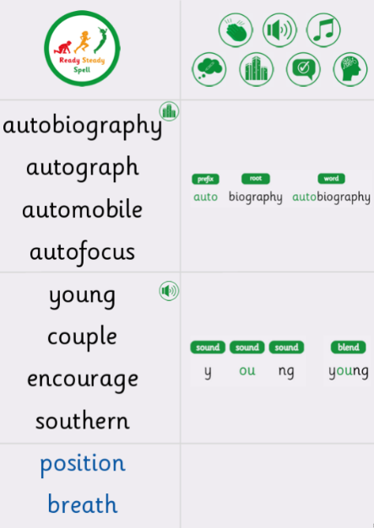
Week 5 (to be tested 27/3/26)  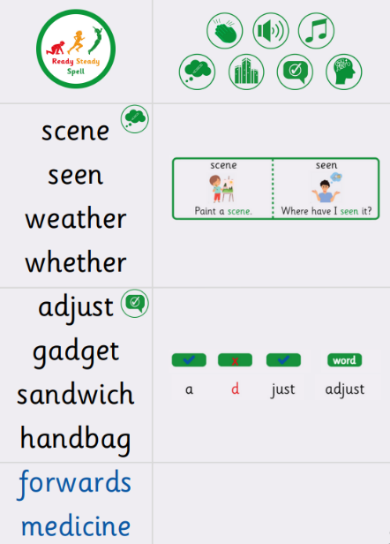 | Week 6 (to be tested 3/4/26)  All spellings from Weeks 2-5!  Try to focus on the ones you found more difficult or didn’t get correct.

