Year 5 Spellings – Spring 1

Week 1 (to be tested 16/01/26)  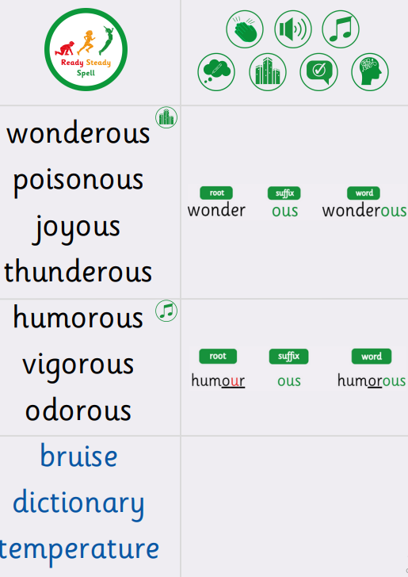 | Week 2 (to be tested 23/1/26)  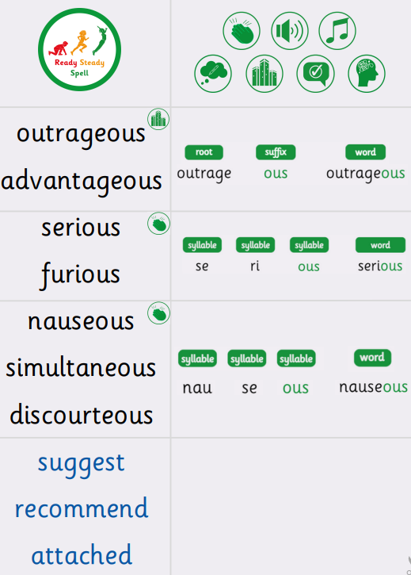
Week 3 (to be tested 30/1/26)  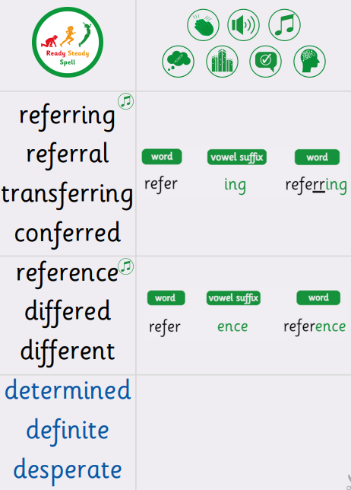 | Week 4 (to be tested 6/2/26)  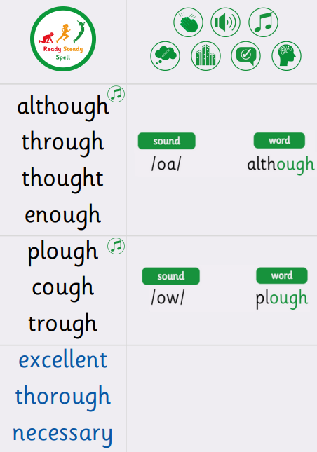
Week 5 (to be tested 13/2/26)

All spellings from Weeks 1-5!

Try to focus on the ones you found more difficult or didn’t get correct.

