Year 5 Spellings – Spring 2

Week 1 (to be tested 06/02/26)  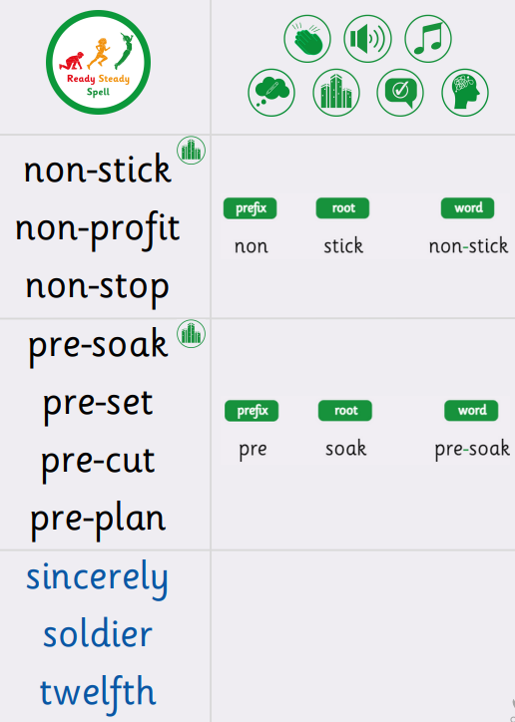 | Week 2 (to be tested 13/03/26)  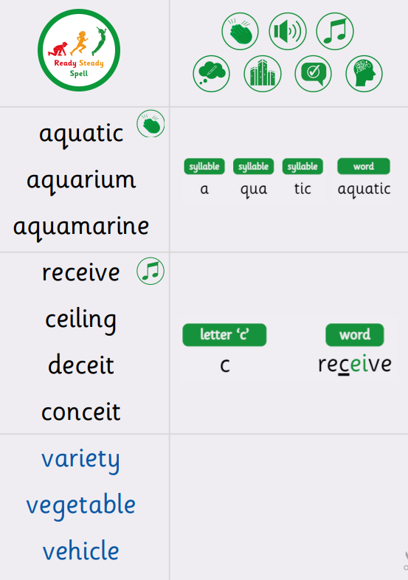
Week 3 (to be tested 27/03/26)  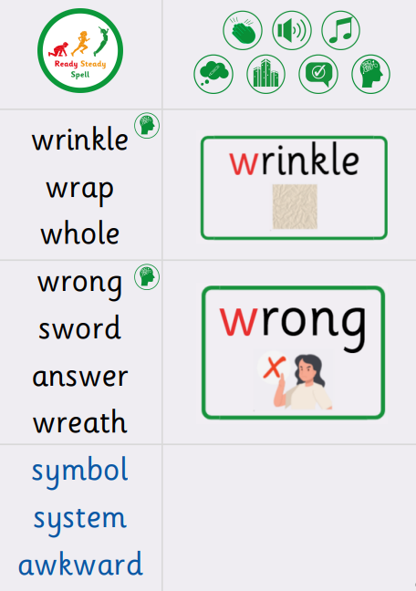 | Week 4 (to be tested 27/03/26) (double test this week as missed last week due to RedRidge Trip)  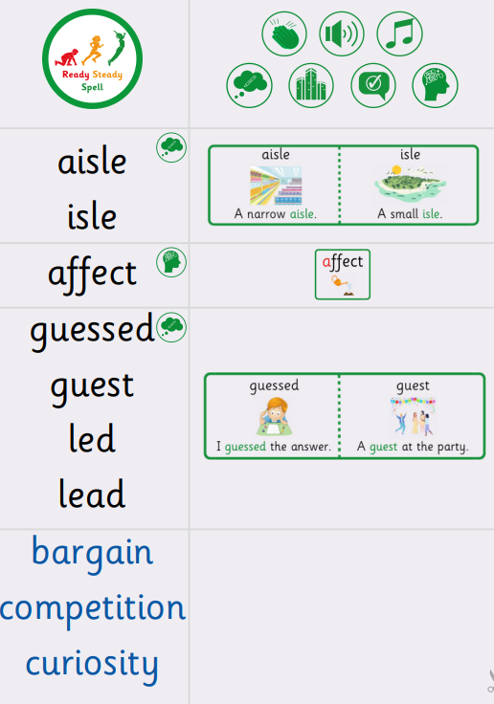
Week 5 (to be tested 03/04/26)

All spellings from Weeks 1-4!

Try to focus on the ones you found more difficult or didn’t get correct.

