Year 4 Spellings – Summer 1

Week 1 (to be tested 17/4/26)  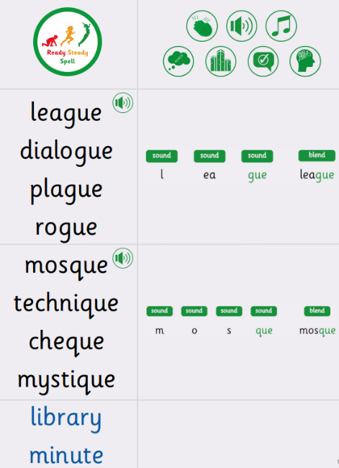 | Week 2 (to be tested 24/4/26)  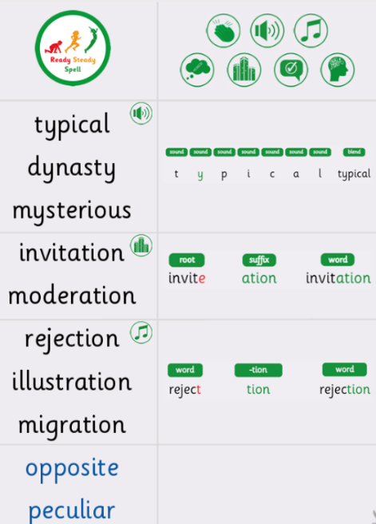
Week 3 (to be tested 1/5/26)  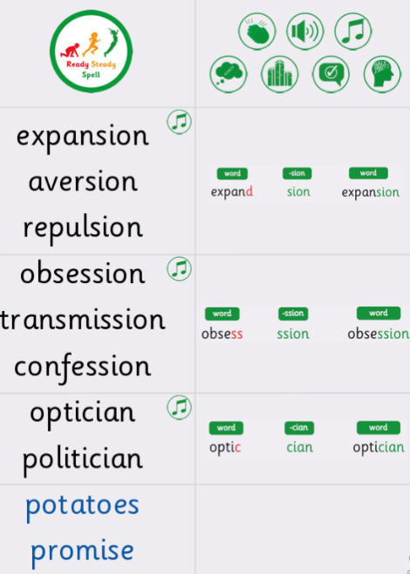 | Week 4 (to be tested 8/5/26)  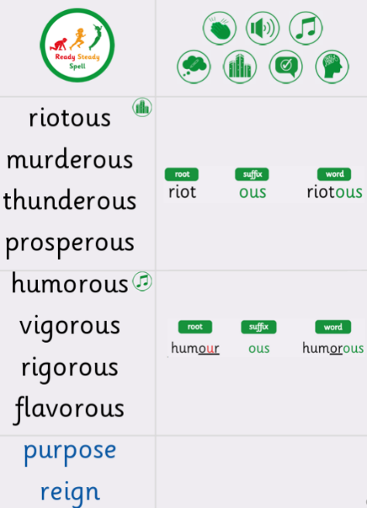
Week 5 (to be tested 15/5/26)  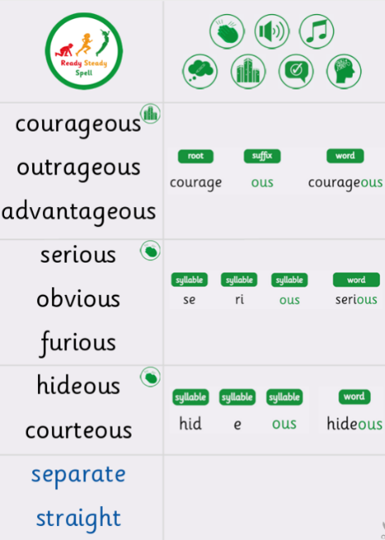 | Week 6 (to be tested 22/5/26)  All spellings from Weeks 2-5!  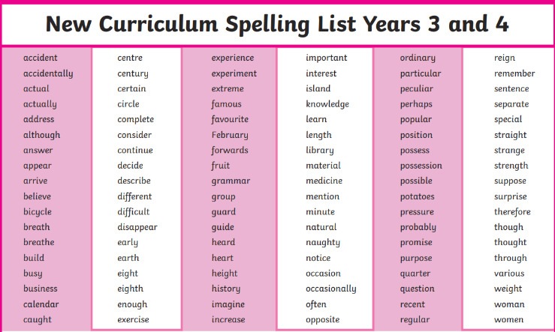  Try to focus on the ones you found more difficult or didn’t get correct.

