Year 5 Spellings – Summer 1

Week 1 (to be tested 17.04.2026)  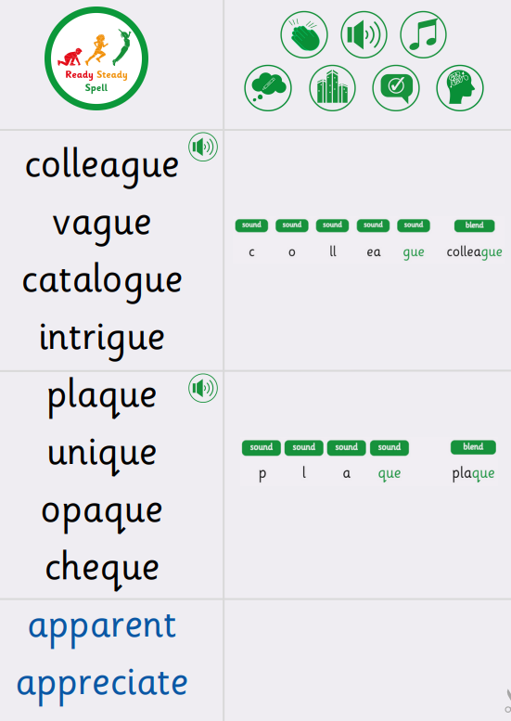 | Week 2 (to be tested 24.04.2026)  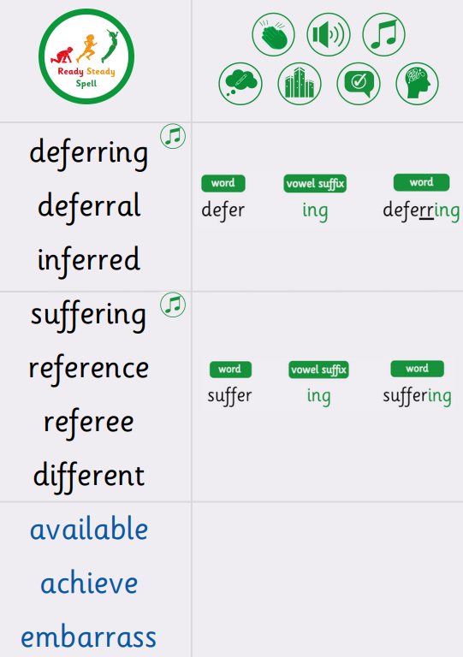
Week 3 (to be tested 01.05.2026)  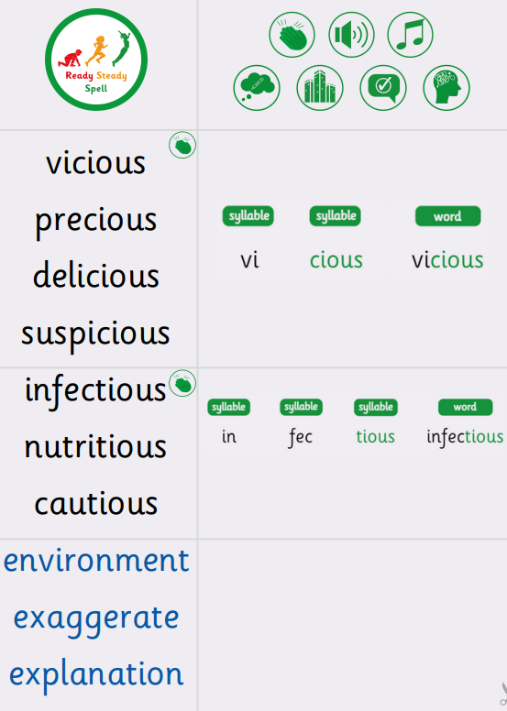 | Week 4 (to be tested 08.05.2026)  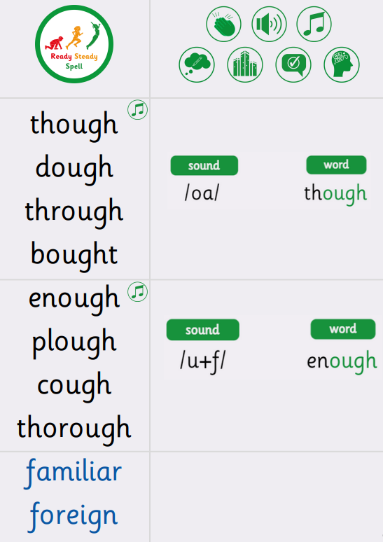
Week 5 (to be tested 15.05.2026)  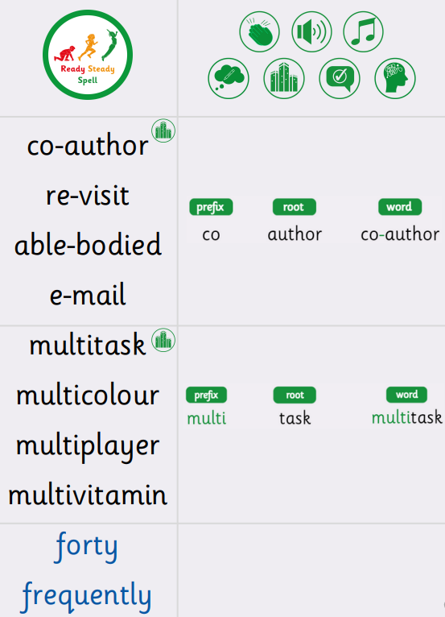 | Week 6 (to be tested 22.05.2026)  All spellings from Weeks 1-4!  Try to focus on the ones you found more difficult or didn’t get correct.

