St Mary’s School Uniform Policy
At St Mary’s, we endeavour to make sure that the cost of our school uniform is affordable.
When considering costs, we have taken into account the total cost of all uniform or clothing items parents or carers will need to buy.
This includes:
- PE kit
- Costs where parents or carers are likely need to buy multiple of the same item (e.g., where pupils need spares, or are likely to grow out of an item quickly)
Changes to Uniform
- There have been no changes to our uniform policy in recent years. However, if a change to uniform should occur, we will allow pupils to continue to wear their old uniform for a reasonable period.
- There are no variations in uniform between groups of pupils as this would make it harder for parents to pass items between siblings.
- There is no difference in cost between the uniform according to gender preference. Skirts, should any pupil of any gender wish to wear one, are no different in price to trousers.
Current Uniform
Integral to school policy is encouraging children to be proud of their school and to identify with it. Therefore, the following uniform is worn:

*Grey trousers/shorts
*Grey skirts or tunics.
*White shirts worn with school tie.
*Green sweatshirts/cardigans, with school logo.
*School Baseball cap (optional)

Summer uniform options:
*green & white classic gingham dress
*Showerproof jacket/Storm jacket in green with St Mary’s logo
Sensible, smart black school shoes are required. Trainers are not allowed other than for outdoor PE.

PE Uniform:
*Black shorts
*Green Polo shirt with school logo
*Black slip-on plimsolls.
*Trainers (for outdoor PE only)
*Black jogging bottoms, school logo is optional

To help keep costs down, the use of branded uniform items has been kept to a minimum and regular discussion with the supplier keeps cost within reasonable pricing band. Any parents struggling to purchase branded items should contact the school for assistance. School also has a large collection of second-hand uniforms available in a range of sizes. Spare uniform is available for parents.

Uniform (branded and non-branded) can be purchased from:
Triffic Togs
Address: 73 Wheelock St, Middlewich CW10 9AE
Phone: 01606 835585
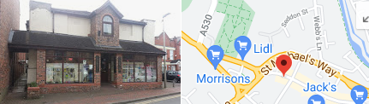

Badged
Address: Unit 5, Springvale Business Centre, Millbuck Way, Elworth, Sandbach, CW11 3HY
Phone: 01477 500504

Sam Dale & Son Ltd
The Forge, 12 Macclesfield Road, Holmes Chapel, Crewe, CW4 7NG
Phone: 01477 532258
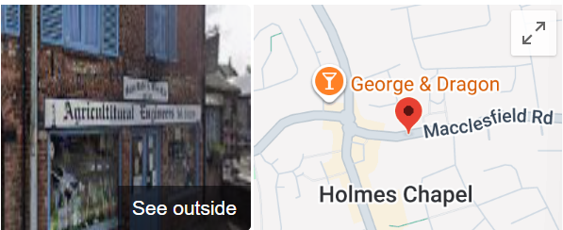

None branded items can be purchased from a wide range of stores such as Asda, Morrisons, the Factory Shop, etc.

