Year 5 Spellings – Summer 2

Week 1 (to be tested 19.06.2026)  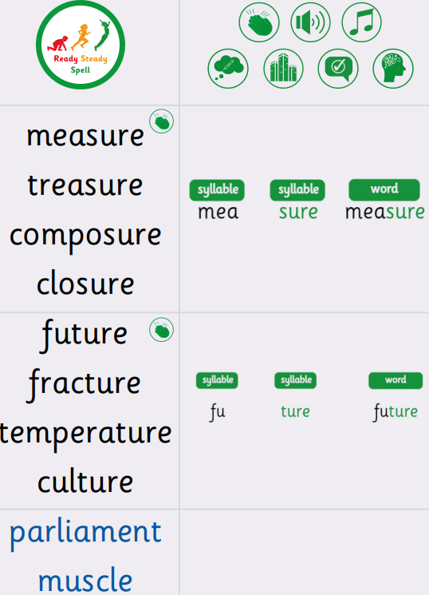 | Week 2 (to be tested 26.06.2026)  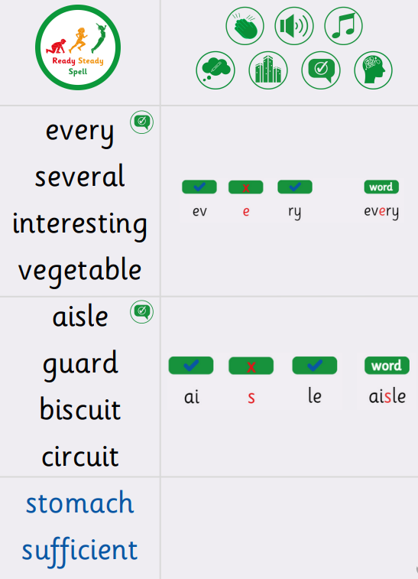
Week 3 (to be tested 03.07.2026)  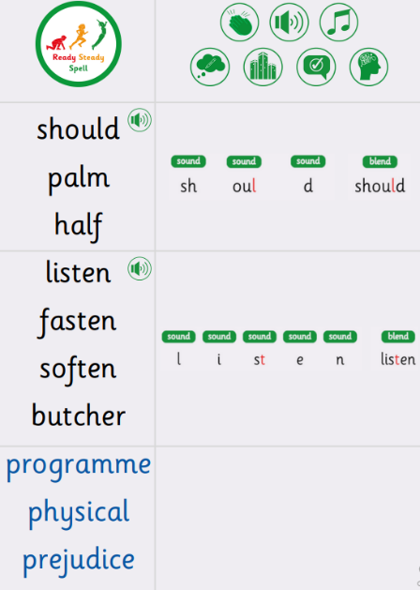 | Week 4 (to be tested 10.07.2026) – next test will be Monday.  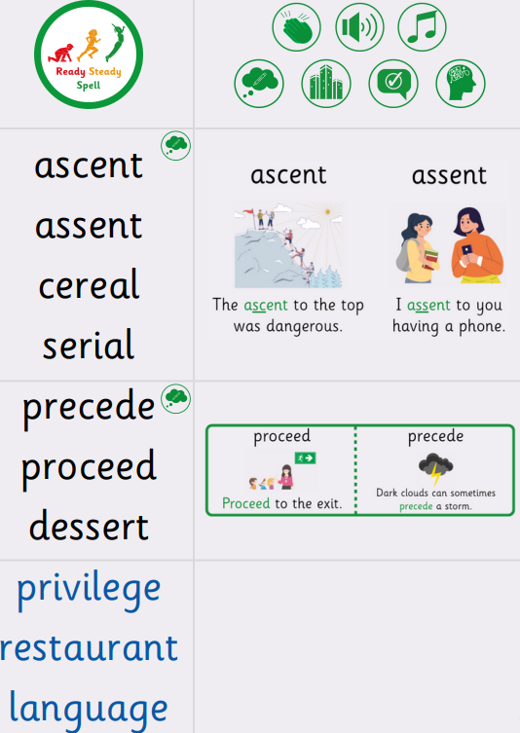
Week 5 (to be tested 13.07.2026) – 2 tests this week!  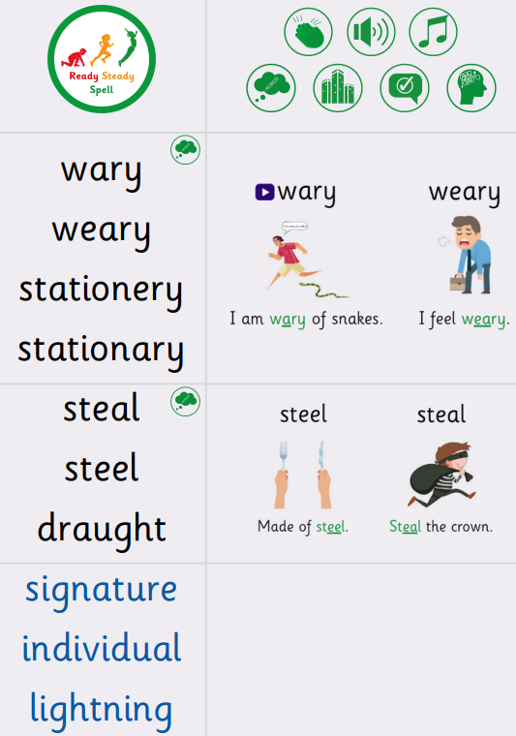 | Week 5 (to be tested 17.07.2026) – sorry I know it is the last day!  All spellings from Weeks 1-5!  Try to focus on the ones you found more difficult or didn’t get correct.

