ST MARY’S CATHOLIC PRIMARY LONG TERM OVERVIEW 2026-2027 – YEAR 4

Y4 | Autumn 1 | Autumn 2 |  | Spring 1 |  | Spring 2 | Summer 1 |  |  | Summer 2
ENGLISH
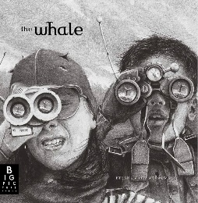

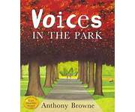
CORE TEXT |  | 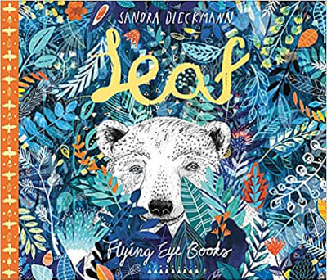 | 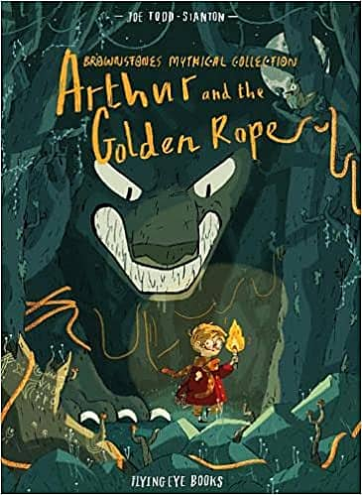 |  | 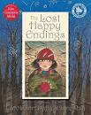 |  |  | 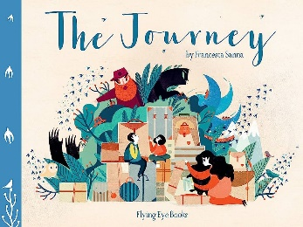 | 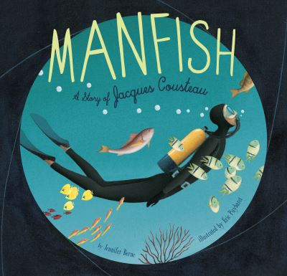
WRITING UNITS | Setting Narrative  Newspaper Report |   Outsider Narrative  Non-Chronological Report | Myth  Information Guide |  | Twisted Narrative  Persuasive Letter |  |  | Refugee Narrative  Diary | Invention Narrative  Biography
CLASS READS | The World’s Worst Children  (David Walliams) | Class Choice | Rumaysa A Fairytale  (Radiya Hafiza) |  | Rumaysa A Fairytale  (Radiya Hafiza) |  |  | The Tale of Despereaux  (Kate DiCamillio) | The Tale of Despereaux  (Kate DiCamillio)
MATHS
MATHS | Place Value  Addition and Subtraction | Measure (perimeter)  Multiplication and Division | Multiplication and Division  Measure (Area) |  | Fractions  Decimals |  |  | Decimals  Money  Time | Statistics  Geometry (angles and 2D shapes)  Geometry (position and direction)
RE
RE | Creation & Covenant | Prophecy & Promise | Galilee to Jerusalem |  | Desert to Garden |  |  | Ends of the Earth | Dialogue & Encounter
Science
Science | States of Matter | States of Matter | Electricity |  | Sound |  |  | Living things and their habitats | Animals Including Humans – Teeth, Digestive System & Food Chains
Computing
Teach computing | Computing systems and networks – The Internet | Creating media - Audio production | Programming A – Repetition in shapes |  | Data and information – Data logging |  |  | Creating media – Photo editing | Programming B – Repetition in games
History
History | How have children’s lives changed? | How have children’s lives changed? | How hard was it to invade and settle in Britain? |  | How hard was it to invade and settle in Britain? |  |  | How did the achievements of the Ancient Maya impact their society and beyond? | How did the achievements of the Ancient Maya impact their society and beyond?
Geography
Geography | What are rivers and how are they used? | What are rivers and how are they used? | Why are rainforests important to us? |  | Why are rainforests important to us? |  |  | Where does our food come from? | Where does our food come from?
Art and Design
Art | KAPOW  Drawing: Exploring tone, texture and proportion | KAPOW  Drawing: Exploring tone, texture and proportion | KAPOW  Painting and mixed media: Light and dark |  | KAPOW  Painting and mixed media: Light and dark |  |  | KAPOW  Craft and design: Fabric of nature | KAPOW  Craft and design: Fabric of nature
Design and Technology
DT | KAPOW  Textiles: Fastenings | KAPOW  Textiles: Fastenings | KAPOW  Electrical Systems: Torches |  | KAPOW  Electrical Systems: Torches |  |  | KAPOW  Digital World: Mindful moments timer | KAPOW  Digital World: Mindful moments timer
Music
Music | KAPOW  Adapting and transposing motifs (Theme: Romans) | KAPOW  Rock and Roll | KAPOW  Haiku, music and performance (Theme: Hanami festival) |  | Wider opportunities |  |  | Wider opportunities | Wider opportunities
PSHE
PSHE | Created and Loved by God | Created and Loved by God | Created and Loved by God |  | Created to Love Others |  |  | Created to Love Others | Created to Live in Community
PE
PE | Tag rugby  Strength and Flexibility | Basketball  Dance | OAA  Dodgeball  Swimming |  | Tennis  Gymnastics – movement  Swimming |  |  | Cricket  Circuits(H&F) | Athletics  Badminton
MFL
MFL | Dates.  Food and drinks. | Say you (or someone else) are hungry / thirsty.  Say you (or someone else) want something to eat or drink. | Opinions on food. |  | Telling the time on the hour. |  |  | Telling the time including minutes. | Personal subject pronouns and present tense of avoir.

