ST MARY’S CATHOLIC PRIMARY LONG TERM OVERVIEW 2026-2027 – YEAR 1/ 2

Y1/2 |  | Autumn 1 |  | Autumn 2 |  | Spring 1 |  | Spring 2 | Summer 1 |  |  | Summer 2
ENGLISH
RE |   Creation & Covenant |  |   Prophecy & Promise |  |   Galilee to Jerusalem |  |   Desert to Garden |  |  |   To the Ends of the Earth |   Dialogue & Encounter
CORE TEXT | 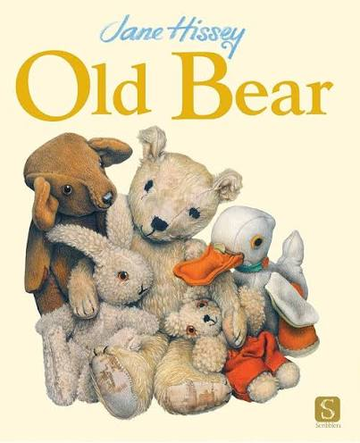 |  | 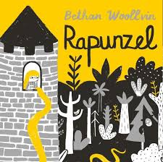 |  | 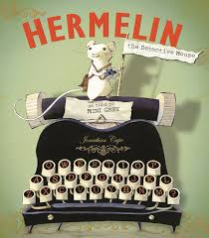 |  | 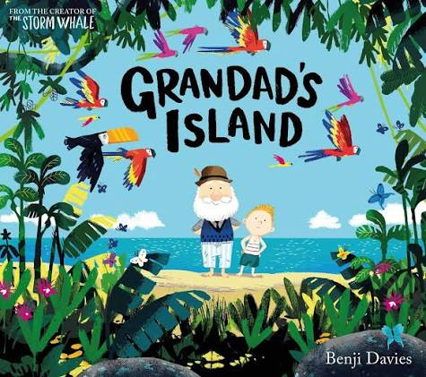 |  |  | 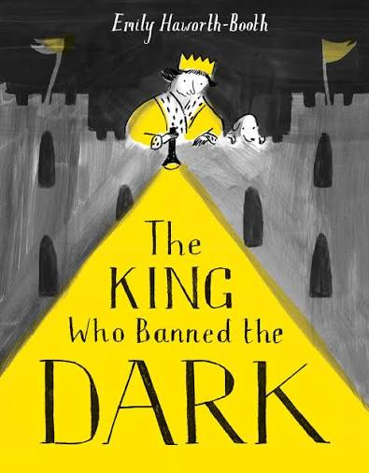 | 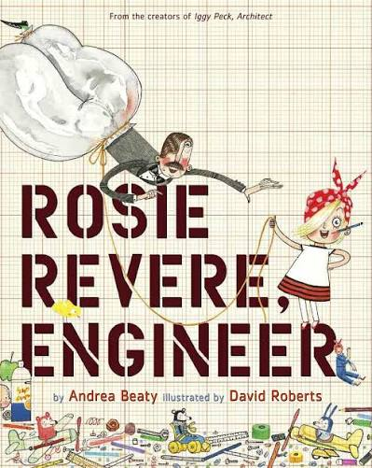
ENGLISH UNITS | Old Bear  by Jane Hissey  Fiction Outcome: Finding story sentences  Non-fiction Outcome: Message sentences |  | Rapunzel  by Bethan Woollvin  Fiction Outcome: Traditional Tale sentences  Non-fiction Outcome: Trap sentences |  | Hermelin  By Mini Grey  Fiction Outcome: Detective story sentences  Non-fiction Outcome: Letter sentences |  | Grandad’s Island  by Benji Davies  Fiction Outcome: Return Narrative  Non-fiction Outcome:  Information text |  |  | The King Who Banned the Dark  by Emily Haworth-Booth  Fiction Outcome: Banning narrative  Non-fiction Outcome: Persuasive letter | Rosie Revere, Engineer  by Andrea Beaty  Fiction Outcome: Invention Narrative  Non-fiction Outcome: Explanation Text
MATHS
Maths | Place Value  Addition and Subtraction |  | Addition and Subtraction  Money  Multiplication and Division |  | Multiplication and Division  Statistics  Properties of shapes |  | Properties of shapes  Fractions  Measurement – Length and Height |  |  | Position and Direction  Problem Solving  Time | Measurement – Mass, Capacity and Temperature  Investigations
Science
Science | Every day Materials & Uses of Everyday Materials |  | Seasonal Changes  Living Things and Their Habitats |  | Living Things and Their Habitats  Animals including humans |  | Animals including humans |  |  | Plants | Plants
Computing
Computing | Online Safety  Computer Systems and networks |  | Creating media – photography |  | Programming – A  Robot algorithms |  | Data & Information |  |  | Creating media - music | Programming B  Programming quizzes
History
History | What is history? |  | What is history? |  | How was school different in the past? |  | How was school different in the past? |  |  | What is a monarch? | What is a monarch?
Geography
Geography | Where am I? |  | Where am I? |  | Would you prefer to live in a hot or a cold place? |  | Would you prefer to live in a hot or a cold place? |  |  | What is it like to live by the coast? | What is it like to live by the coast?
Art and Design
Art | Drawing: Understanding tone and texture |  | Drawing: Understanding tone and texture |  | Painting & Mixed Media: Life in Colour |  | Painting & Mixed Media: Life in Colour |  |  | Craft and Design: Map it out | Craft and Design: Map it out
Design and Technology
DT | Mechanisms – Making a Moving Monster |  | Mechanisms – Making a Moving Monster |  | Cooking & Nutrition: Smoothies |  | Cooking & Nutrition: Smoothies |  |  | Textiles: Simple sewing and pouches | Textiles: Simple sewing and pouches
Music
Music | Myths & Legends |  | Orchestral Instruments |  | Musical Me |  | Dynamics, timbre, tempo & motifs (Space) |  |  | On this island: British songs & sounds | African Call & Response Song
PE
PE | Ball Skills (throwing & catching)  Dance – Seasons |  | Fun fitness (Circuits)  Gymnastics – Traditional tales |  | Ball Skills (Invasion games)  Dance – Gunpowder plot |  | Striking and fielding  (Bat and Ball)  Gymnastics – Animals |  |  | Athletics (incorporating flexibility, strength, technique control & balance) | Tri Golf to incorporate balance & co-ordination  Outdoor Adventurous Activity  (OAA)
MFL
MFL | Greetings. Say their name and asking others. |  | Say how you feel and ask others. |  | Numbers to 20 in and out of sequence. |  | Say how old they are and ask others. |  |  | Say 12 colours in French. | Say what colour something is.
PSHE
PSHE | Let the children come  I am unique  Picture News |  | Girls and Boys  Picture News |  | Clean and Healthy (My body)  Feelings, likes and dislikes  Picture News |  | Feelings inside and out  Super Susie gets angry  The cycle of life  Picture News |  |  | Three in One  Picture News | Who is my neighbour?  The communities we live in  Picture News

