Year 5 Spellings – Autumn 1

Week 1 (to be tested 18/09/26)  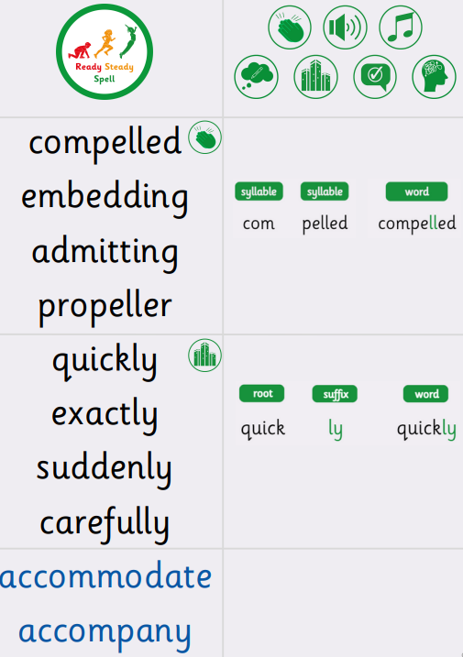 | Week 2 (to be tested 25/9/26)  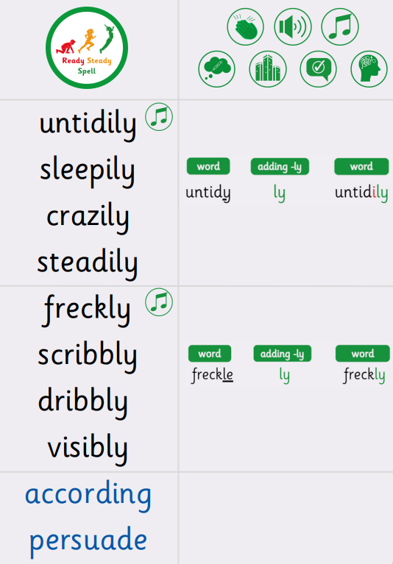
Week 3 (to be tested 2/10/26)  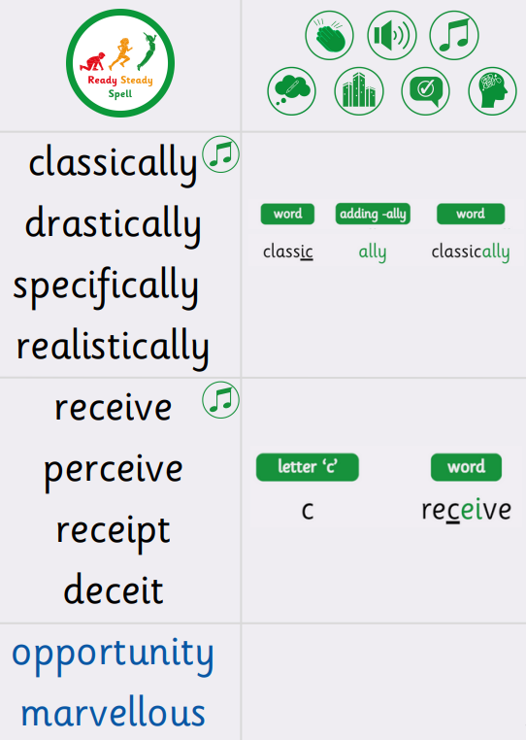 | Week 4 (to be tested 9/10/26)  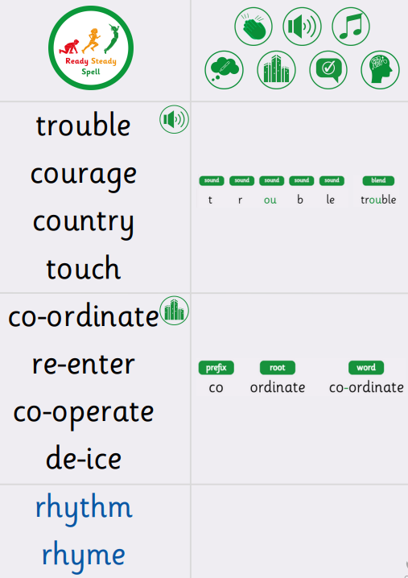
Week 5 (to be tested 16/10/26)  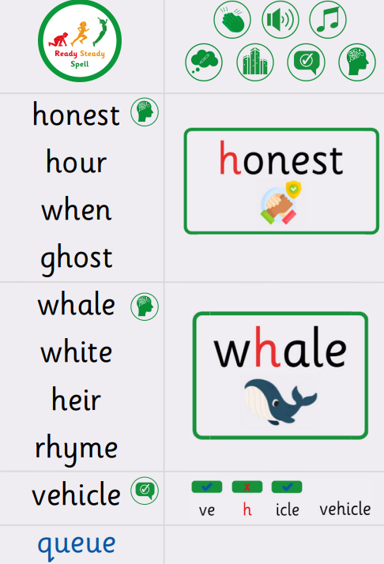 | Week (to be tested 23/10/26)  All spellings from Weeks 1-5!  Try to focus on the ones you found more difficult or didn’t get correct.

