Year 2 Spellings – Autumn 1

Week 1 (to be tested 18.9.26)  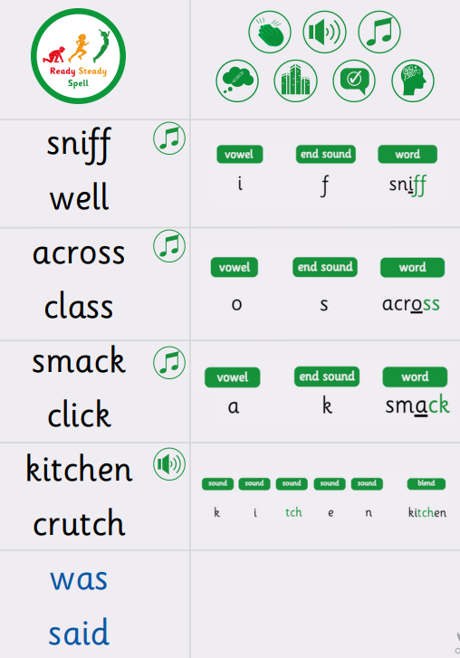 | Week 2 (to be tested 25.9.26)  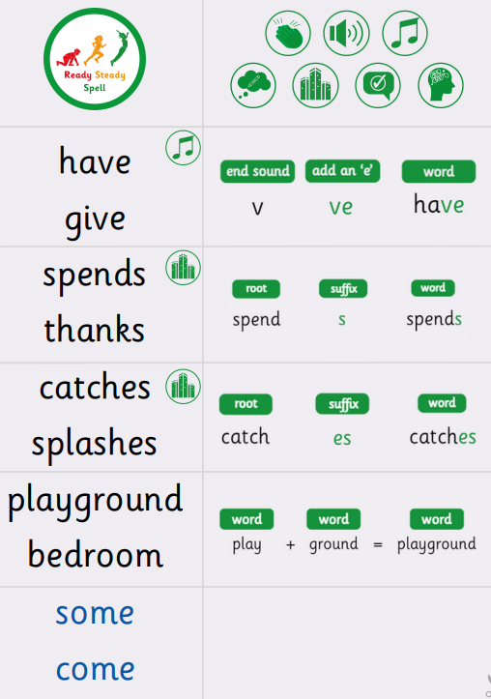
Week 3 (to be 2.10.26 tested )  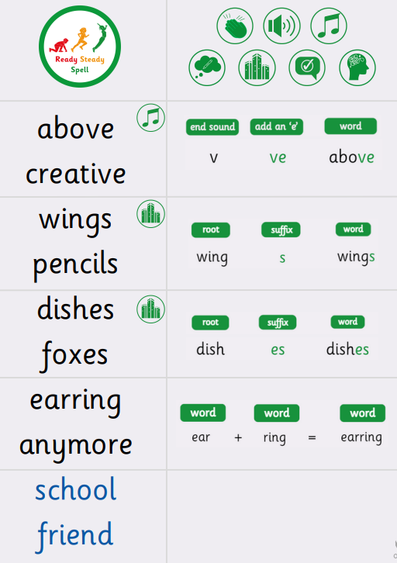 | Week 4 (to be tested 9/10/26)  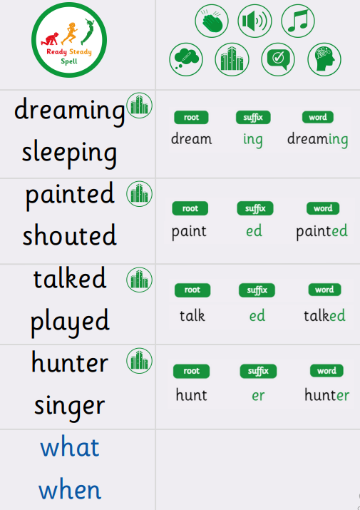
Week 5 (to be tested 16/10/25)  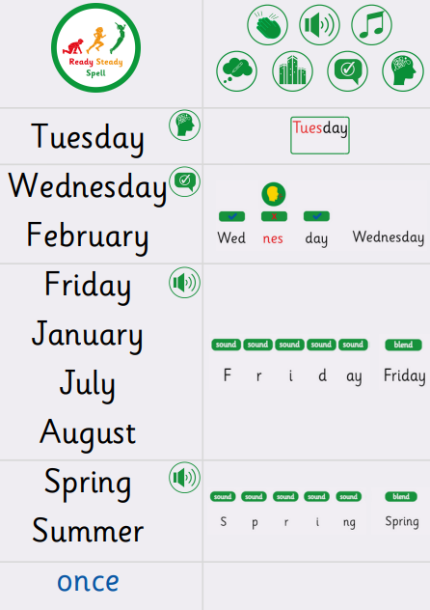 | Week 6 (to be tested 23/10/26)  All spellings from Weeks 1-5!  Try to focus on the ones you found more difficult or didn’t get correct.

