Spellings WB 14th Sept (Test 18th Sept)  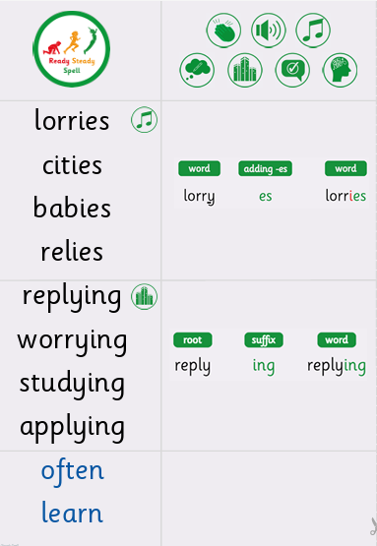 | Spellings WB 21st Sept (Test 25th Sept)  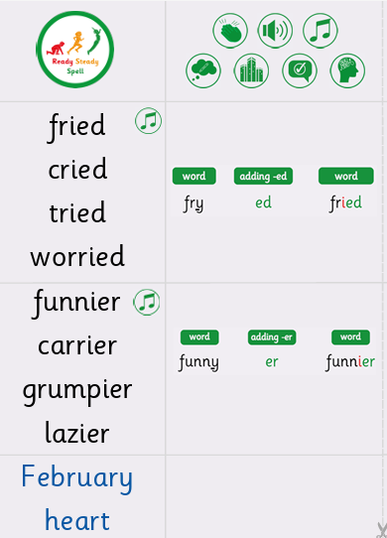
Spellings WB 28th Sept (Test 2nd Oct)  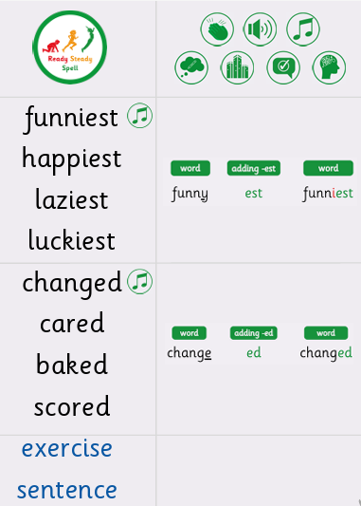 | Spellings WB 5th Oct (Test 9th Oct)  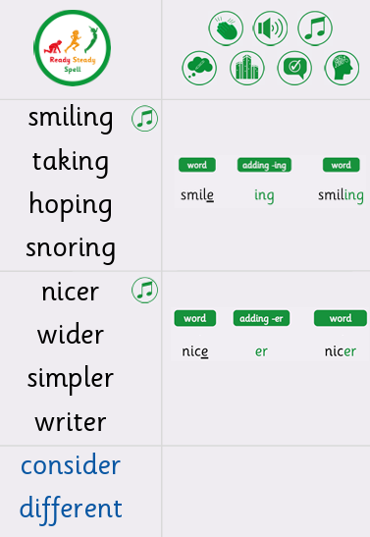
Spellings WB 12th Oct (Test 16th Oct)


