 | INSET Day |  | School Holidays |  | Bank Holidays
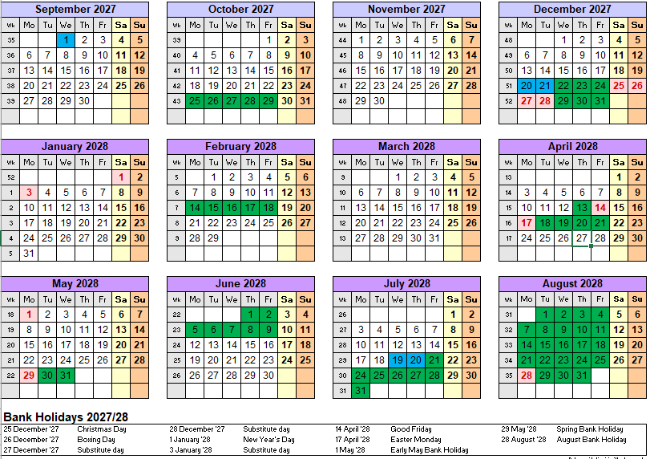
AUTUMN 2027 | SPRING 2028 | SUMMER 2028
Thursday 2nd September 2027 –  Friday 22nd October 2027  (37 days) | Tuesday 4th January 2028 –  Friday 11th February 2028  (29 days) | Monday 24th April 2028 –  Friday 26th May 2028  (2 days)
HALF TERM  Monday 25th October 2027 to  Friday 29th October 2027 | HALF TERM  Monday 14th February 2028 –  Friday 18th February 2028 | HALF TERM  Monday 29th May 2028 –  Friday 9th June 2028
Monday 1st November 2027 -  Friday 17th December 2027  (35 days) | Monday 21st February 2028 –  Wednesday 12th April 2028  (38 days) | Monday 12th June 2028 –  Tuesday 18th July 2028  (27 days)
CHRISTMAS HOLIDAY  Monday 20th December 2027 -  Tuesday 4th January 2027 | SPRING BREAK  Thursday 13th April 2028 -  Friday 21st April 2028 | SUMMER HOLIDAY  Wednesday 19th July 2028 –  Thursday 31st August 2028

INSET DAYS = 5 DAYS
1st September 2027 20th December 2027 21st December 2027
19th July 2028 20th July 2028

TOTAL TEACHING DAYS = 190 DAYS

