Year 4 Spellings – Autumn 2

Week 1 (to be tested 2/11/26)  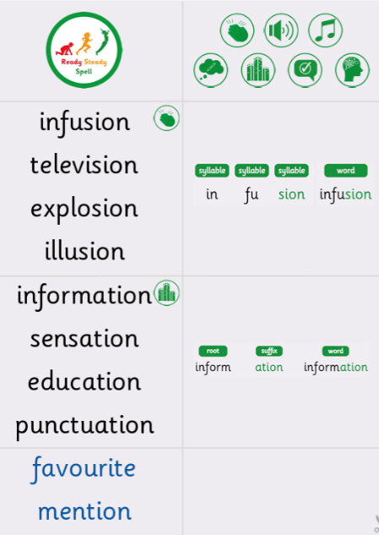 | Week 2 (to be tested 9/11/26)  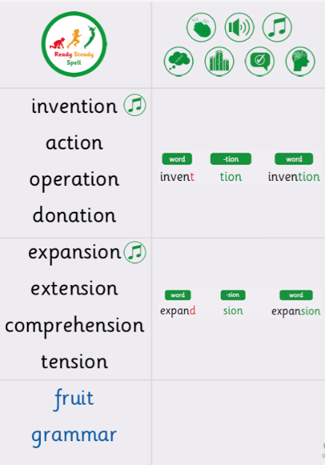
Week 3 (to be tested 16/11/26)  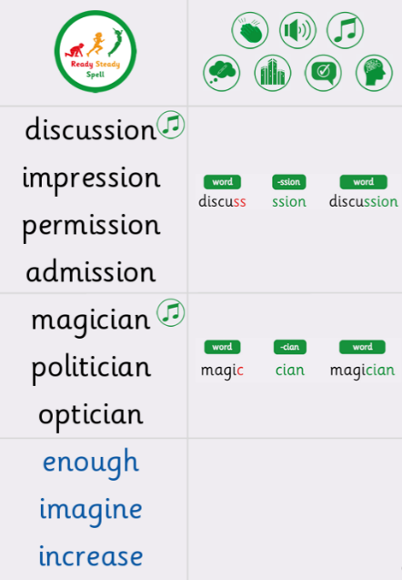 | Week 4 (to be tested 23/12/26)  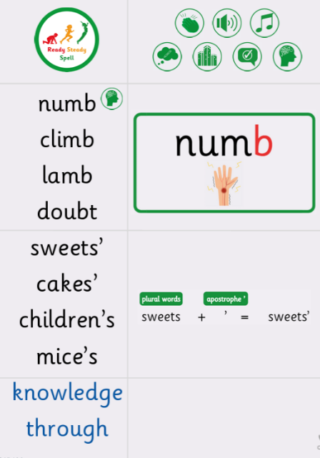
Week 5 (to be tested 30/11/25)  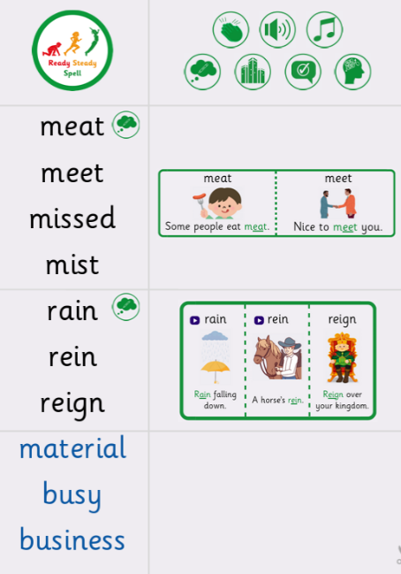 | Week 6 (to be tested 7/12/26)  All spellings from Weeks 1-5!  Try to focus on the ones you found more difficult or didn’t get correct.

