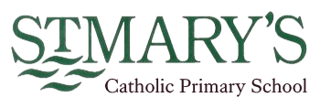
Early Years statement.
Curriculum aims.

At St. Mary’s, we are a proud Catholic school, with Christ at the heart of everything we do. We believe that every child is a gift from God, created in his own image and likeness. Our Mission Statement affirms that our aim is that every child reaches their full potential.
Pupils’ learning and development is at the centre of our school’s curriculum; it is broad, balanced and challenging, ensuring pupils develop the skills necessary to succeed in life after primary school. Our welcoming and nurturing environment, based on the Gospel Values, also allows every individual to develop their spiritual, moral, social and cultural growth.
We recognise that our children are the leaders of tomorrow and that we must prepare them to play an active and responsible role in society.

Early Years Mission Statement.

In the Early Years at St. Mary’s every individual is valued, cherished and enabled to develop and fulfil their potential. Opportunities and experiences are given to foster attitudes of mutual respect and recognition of their own and others’ achievements with the Gospel values at the heart of all that we do. The Early Years focuses on the development of the whole unique child, in line with the seven areas of learning established in the Foundation Stage Curriculum. These areas come under the umbrella of Prime areas or specific areas. All areas of learning are important and interconnected. The prime areas are crucial for igniting children’s curiosity and enthusiasm for learning, and for building their capacity to learn, form relationships and thrive. This vital, early stage in a child’s life plays an important contribution to their later performance, both academically and socially.

INTENT

At St Mary’s, we aim to provide a safe, nurturing environment which promotes the highest standard of education for our youngest pupils. Our Early Years team is committed to providing an environment that is rich with possibilities, develops children’s independence and puts children right at the centre of their own learning.
The aims of our EYFS curriculum are to develop young pupils who are:
Competent learners (through play)
Resilient
Capable
Confident
Communicators
Independent
Creative
Curious and inquisitive
Self-assured
Accepting and empathetic
Positive
Courageous

Ready for the transition into Year 1

IMPLEMENTATION

At St. Mary’s we believe that children gain the right and appropriate grounding for their educational journey through a play-based practice with all its rich language, physicality and social interaction. Play is our fundamental principle but alongside this, we also incorporate direct teaching times across each day to introduce and consolidate skills in phonics, language and literacy mathematics and personal and emotional development. We aim to plan exciting, enriched activities under a broad topic theme which are based on the children’s interests through our child-centre approach. Through creative ideas which involve the children and, where possible, are based on real life experiences we create a sense of awe and wonder.
We have a trip to the theatre in the Winter, a school trip in the Summer and a walk to the Church. We invite parents in and members of our local community to talk to us and share their knowledge and experiences. We have external organisations is to provide lessons which enhance our curriculum such as: - Bikeability which helps the children learn how to ride a bike and Barney Bear which provides musical instruments and singing skills. We plan creative days where we bring together all our knowledge, skills and experiences and celebrate through fancy dress, baking and singing. Children in Reception classes have the opportunity to join in some afterschool clubs such as: - multi sports and dance.
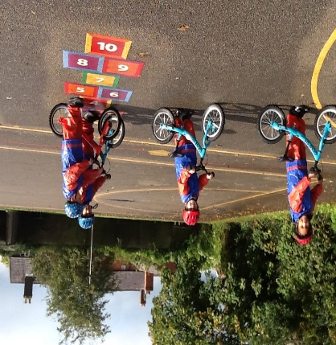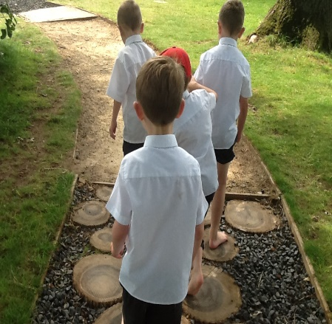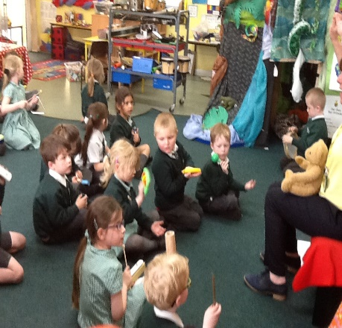
We provide children with the opportunity to be explorers, be actively involved in their learning, as well as creative and critical thinkers through the planning of open-ended tasks. We aim to foster curiosity through carefully planned learning environments enabling children to demonstrate those key characteristics of effective learning and we nurture children’s preferred learning styles.

We value the importance of learning outdoors and enjoy using our special early year’s outdoor area and garden within our everyday planning. We make good use of the school grounds, especially the ‘Forest Area’ regularly.
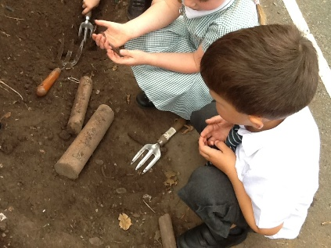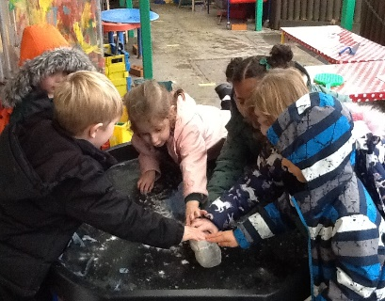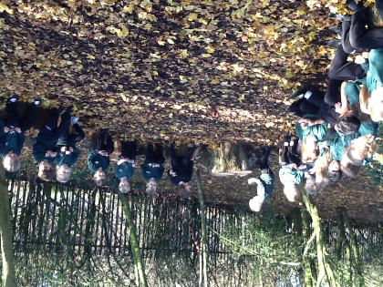
At St Mary’s we ensure that our learning environments provide stimulating resources which are relevant to all the children’s cultures and communities. That they offer rich learning opportunities through play and playful teaching. We provide support for children to take risks and explore in our indoor and outdoor learning environment.
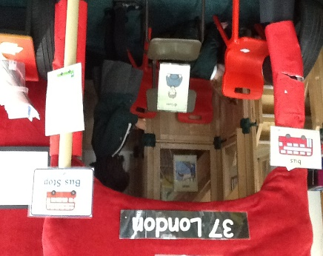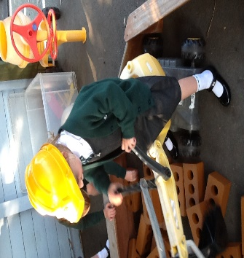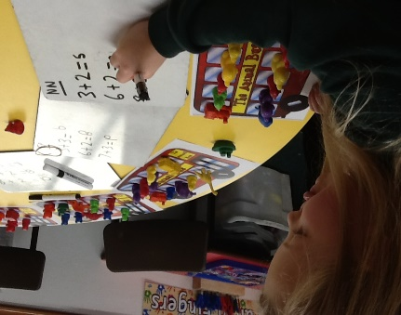
We also know that parents are children’s first and most enduring educators and we value being partners with them in their child’s education. We look to forge positive relationships with parents to enable us to support learning both at home and school. We share the children’s learning through a range of ways including; teacher/parent meetings, sharing paper and electronic Learning Journals and workbooks, positive notes/stickers, parent voice, and an open-door policy. We invite families in to join us for different occasions such as: - Tears and Tissues, Chapel reflections, end of theme assemblies, McMillan Coffee Morning, Christmas Celebrations, Mystery Reader, Sports Days.
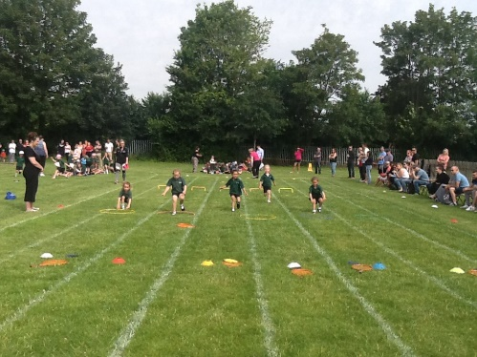
INCLUSION

St Mary's Catholic Primary School is an inclusive school, which supports and encourages all children to achieve. We are committed to high quality teaching and learning opportunities with Quality First Teaching at the core of curriculum planning. Pupils with special education needs (including gifted and talented children) receive support where appropriate, including differentiated work and small group support from TA's.

IMPACT

St. Mary’s EYFS curriculum provides a sustained high quality, well planned and progressive curriculum for the unique child.
The delivery of our curriculum within the areas of learning are underpinned by previous experiences. This allows children to make a positive start on their educational journey. We ensure our staff have good knowledge of child development to ensure this is tracked clearly and everyone has a good understanding of the progress and attainment of our youngest learners.

The positive relationships developed between staff and children ensure that the children are self-confident, with a good degree of self-esteem and resilience. The children’s level of involvement ensures they are intensely engaged in activities which encourage deep level learning and development. This can be seen through the active learning environment during ‘busy time’.
Pupil progress is regularly reviewed through daily communication within the EYFS team, pupil progress meetings, internal staff meetings and moderation of children’s profiles (both in school, across schools and within Cheshire East). This ensures that all judgments of attainment are accurate and clear.
All children’s progress is tracked termly and attainment is closely monitored. By the end of the EYFS phase (end of Reception), all children will have had a completed Early Years Foundation Stage Profile (EYFSP) outlining their attainment across the phase, in line with the statutory guidelines. From this it is judged whether children are achieving at age related expectations and have achieved a ‘good level of development’ (GLD).

We measure the impact of our curriculum through the following methods: -
- Formative assessment (assessment for learning) based on observations of the children in action, both in self-chosen play and planned activities.
- Images and videos of the pupil’s practical learning.
- Interviewing the pupils about their learning (pupil voice).
- Summative assessment of pupil’s learning using NFER base line, termly assessment activities, benchmarking reading and discussions about the child’s development within the EYFS team.
- Learning journeys, work books, displays.

Assessment
Children are continually assessed through planned and spontaneous observations, photographs, videos and information drawn from discussions with the children and their parents. These are recorded using class books and a digital ‘Learning Journal’ system called Tapestry. Parents contribute at any time to the learning journal by the addition of observations and/or photographs and comments on observations made by school staff. This information is used by the class teacher to assess children’s attainment against the Early Learning Goals.
The well-being of all our pupils is of paramount importance here at St Mary’s. We ensure our pupils are ready to access learning through the assessment of their level of well-being and involvement. Opportunities are provided for children to develop this, including the notion of belonging, coping, core self and resilience.
Useful documents: -
EYFS Policy
Early Years Long Term Plan
Early Years Topic Map Objectives
Early Years Outcomes
Development Matters

