History
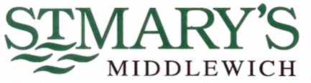

Curriculum Aims

At St. Mary’s, we are a proud Catholic school, with Christ at the heart of everything we do. We believe that every child is a gift from God, created in his own image and likeness. Our Mission Statement affirms that our aim is that every child reaches their full potential.
Pupils’ learning and development is at the centre of our school’s curriculum; it is broad, balanced and challenging, ensuring pupils develop the skills necessary to succeed in life after primary school. Our welcoming and nurturing environment, based on the Gospel Values, also allows every individual to develop their spiritual, moral, social and cultural growth.
We recognise that our children are the leaders of tomorrow and that we must prepare them to play an active and responsible role in society.

INTENT
Why do we teach what we teach?
The teaching of history in St Mary’s reflects our Mission Statement. Learning through history, enhances the individual child’s understanding of themselves, the influence of the past on their lives and their place in the wider community. In line with their own personal development and academic capability, children are given the opportunity to acquire a sound knowledge of history and the skills of historical enquiry. They are helped to gain informed understanding of the issues of their own race, gender and culture, and those of others; they are actively encouraged to celebrate diversity. Furthermore, children are given the confidence to challenge negative, prejudiced and stereotyped views of other people, thus living the Gospel values.

History Aims
- To acquire an accurate and increasingly detailed knowledge of the past.
- To develop an interest and enthusiasm for the past.
- To provide an awareness of both their own heritage, and that of others.
- To encourage an appreciation of how the past influences the present.
- To help children acquire life skills (e.g. historical enquiry)
- To be able to recognise what evidence is and evaluate its quality.
- To develop the skill of objective thinking.
- To give the children the means to communicate their understanding in a variety of ways.
- To develop knowledge of chronology within which they can organise their understanding of the past.
- To make links with and apply prior learning.
- To deliver the National Curriculum for History.

IMPLEMENTATION
How do we teach what we teach?
The curriculum design for History in our school is progressive in both skills and knowledge. The curriculum plans are based on the those stated in the 2014 Primary National Curriculum. Teachers plan their termly topics from the Long Term Plans. Medium Term Plans break down the teaching into key knowledge and skills and a clear teaching sequence. Knowledge Organisers are used to support the embedding of key knowledge, skills and vocabulary. The history progression document ensures that there is progression throughout the school.
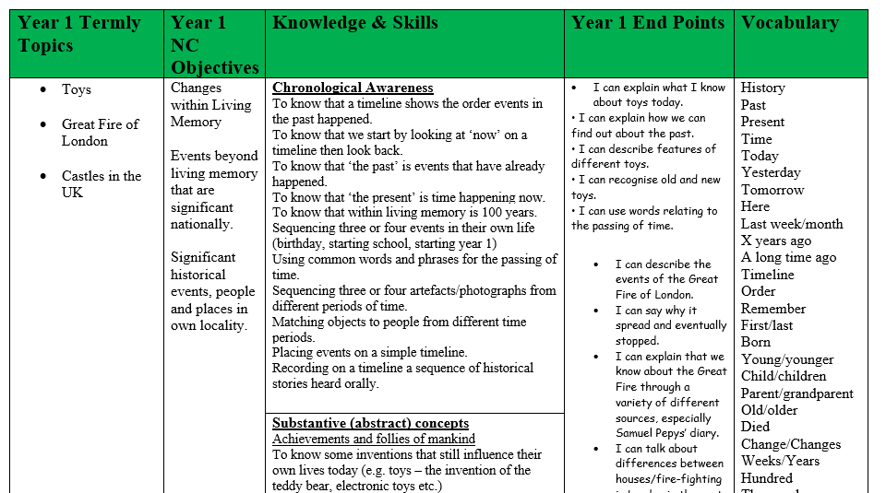
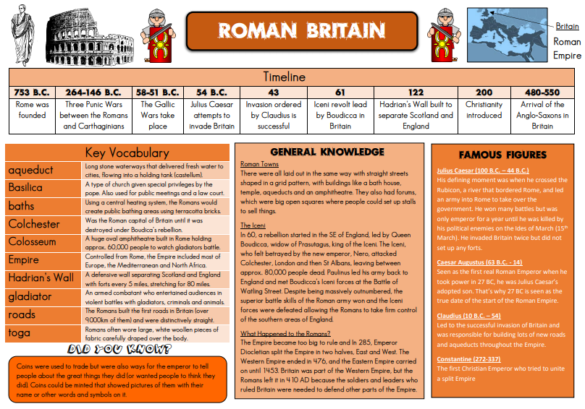
At St Mary’s History lessons in KS1 and KS2 are taught once a fortnight in explicit lessons, however, cross curricular links with other subjects are made where possible. Children are encouraged to ask questions to further their own learning. They are taught how to use historical source material, how to describe and explain historical changes and what caused them, and develop the ability to understand interpretations of history.
We fully appreciate the impact of learning outside of the classroom and incorporate visits to both local and national historic sites and museums. Educational visits can help bring History to life and close links are made with Middlewich Heritage Society.

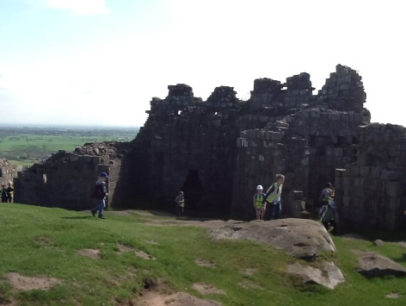

INCLUSION
St Mary's Catholic Primary School is an inclusive school, which supports and encourages all children to achieve. We are committed to high quality teaching and learning opportunities with Quality First Teaching at the core of curriculum planning. Pupils with special education needs (including gifted and talented children) receive support where appropriate, including differentiated work and small group support from TA's.

IMPACT
How do we measure what we teach?
At St Mary’s we focus our teaching on the creative development of knowledge and skills. We measure the impact of our curriculum provision in a variety of ways:
- Carrying assessments of the children’s current knowledge at the beginning and end of a unit.
- Use of mini quizzes or Kahoots at regular intervals during a topic and at the end.
- Spaced Retrieval Practice tasks, with the aid of knowledge organisers.
- Discussion with children, including pupil voice questionnaires carried out by staff and children (History Ambassadors).
- Scrutiny of planning and children’s books.
- Termly Foundation Assessment Reporting proforma.
- Displays
- Project work carried out by children.

