Mathematics

Curriculum Aims

At St. Mary’s, we are a proud Catholic school, with Christ at the heart of everything we do. We believe that every child is a gift from God, created in his own image and likeness. Our Mission Statement affirms that our aim is that every child reaches their full potential.
Pupils’ learning and development is at the centre of our school’s curriculum; it is broad, balanced and challenging, ensuring pupils develop the skills necessary to succeed in life after primary school. Our welcoming and nurturing environment, based on the Gospel Values, also allows every individual to develop their spiritual, moral, social and cultural growth.
We recognise that our children are the leaders of tomorrow and that we must prepare them to play an active and responsible role in society.
INTENT
Why do we teach what we teach?
Within St Mary’s school, under the guidance of our mission statement and the National Curriculum directives, we strive to provide the children with the skills, knowledge and understanding of mathematics necessary for them to be able to play a valued part in society. We achieve this through the development of a fascination for mathematics, the nurturing of a positive and tenacious attitude and the encouragement of an eagerness to investigate, thus allowing each child the opportunity to develop to their full potential.

We intend for all children to access and master the appropriate age related objectives at a similar pace. Knowledge and understanding is extended through looking deeper into elements and a wider variety of problem solving, rather than moving to the following year’s objectives.
Aims
- To develop a love of mathematics through play, investigation and making connections.
- For children to become fluent in the fundamentals of mathematics
- For children to reason mathematically by following a line of enquiry, conjecturing relationships and generalisations, and developing an argument, justification or proof using mathematical language.
- For children to solve problems by applying their mathematics to a variety of routine and non-routine problems.
- For children to be able to use and manipulate concrete resources before moving onto pictorial and abstract problems.
- To promote where we see and use mathematics in everyday life.

IMPLEMENTATION
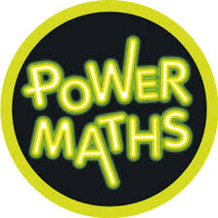
How do we teach what we teach?

At St Mary’s, we use Power Maths as the structure for our planning and teaching in KS1 and KS2. This is supplemented with the use of other resources such as White Rose Maths and NCETM materials. This allows teachers to follow a teaching for Mastery approach, developing a deep and lasting understanding of mathematical procedures and structures. The 5 big areas – Coherence, Representation and Structure, Mathematical Thinking, Fluency and Variation are evident in daily lessons.

During daily lessons, children build their knowledge and understanding through manipulating concrete resources, asking questions, exploring links and using stem sentences to help them explain their understanding. Children are actively encouraged to select concrete resources and are supported in using them to work through problems.
A variety of representations and structures are used to help children to see concepts in different ways. Power Maths helps build the progression of representations throughout the school.

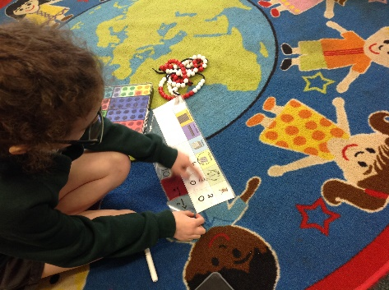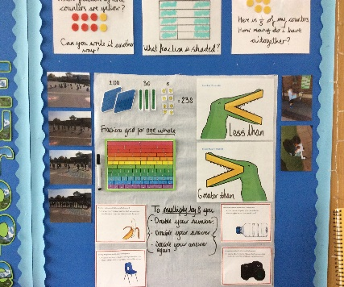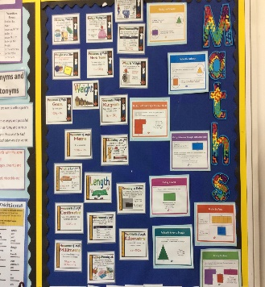

Whilst there are daily mathematics lessons, teachers also use every opportunity to make links with other subjects.

Each classroom has a set of quality resources, supported by a central store of additional resources in the project court. Classrooms reflect the learning taking place and encourage children to visualise and explain their understanding.

INCLUSION
St Mary's Catholic Primary School is an inclusive school, which supports and encourages all children to achieve. We are committed to high quality teaching and learning opportunities with Quality First Teaching at the core of curriculum planning. Pupils with special education needs (including gifted and talented children) receive support where appropriate, including differentiated work and small group support from TA's.

IMPACT
How do we measure what we teach?
Formative assessment strategies are used throughout daily maths lessons, ensuring that all children grasp the necessary understanding of concepts. Discussion, questioning, various Kagan strategies and mini quizzes are just some of the ways in which teachers evaluate the learning taking place. Metacognitive questioning throughout the lessons help the children to plan, monitor and evaluate their own learning.
Verbal and written feedback is shared during lessons. Time is given at the start of lessons to address any misconceptions or further develop thinking. Feedback slides are used to model similar questions and explore greater challenge.

At the end of each unit of work, the children reflect upon their learning and carry out End of Unit Assessments from White Rose Maths. Towards the end of every term, the children are assessed using the Hodder testing materials, giving the children a raw and standardised score. A mistake analysis is carried out to identify and patterns in misconceptions. The children are also assessed termly on their rapid recall of times table facts and are given opportunities to develop their skills through activities such as Maths Rockstars and Percy Parker songs.

Attainment and Progress is recorded, highlighting individual pupils who may not have made sufficient progress. Pupil Progress meetings are held regularly to discuss these children and to explore ways forward. The lowest 20% of children in each class across the school are identified and support is put into place. Attainment and Progress data is shared termly with all staff and Governors.

