ST MARY’S CATHOLIC PRIMARY LONG TERM OVERVIEW 2024-2025 – YEAR 3

Y3 |  | Autumn 1 |  | Autumn 2 | Spring 1 |  | Spring 2 | Summer 1 |  |  | Summer 2
ENGLISH
CORE TEXT | 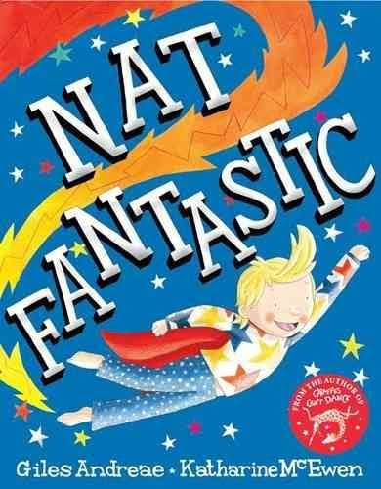 |  | 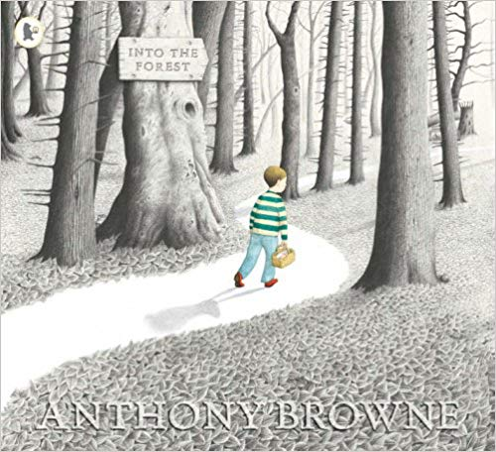 |  | 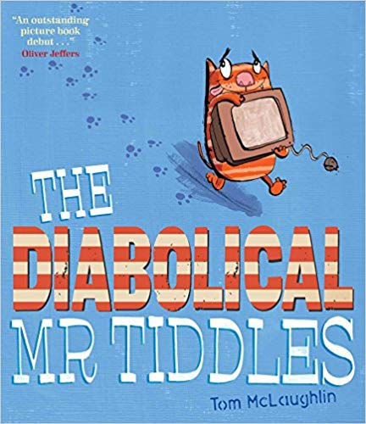 | 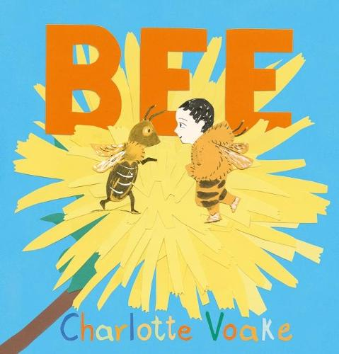 |  |  | 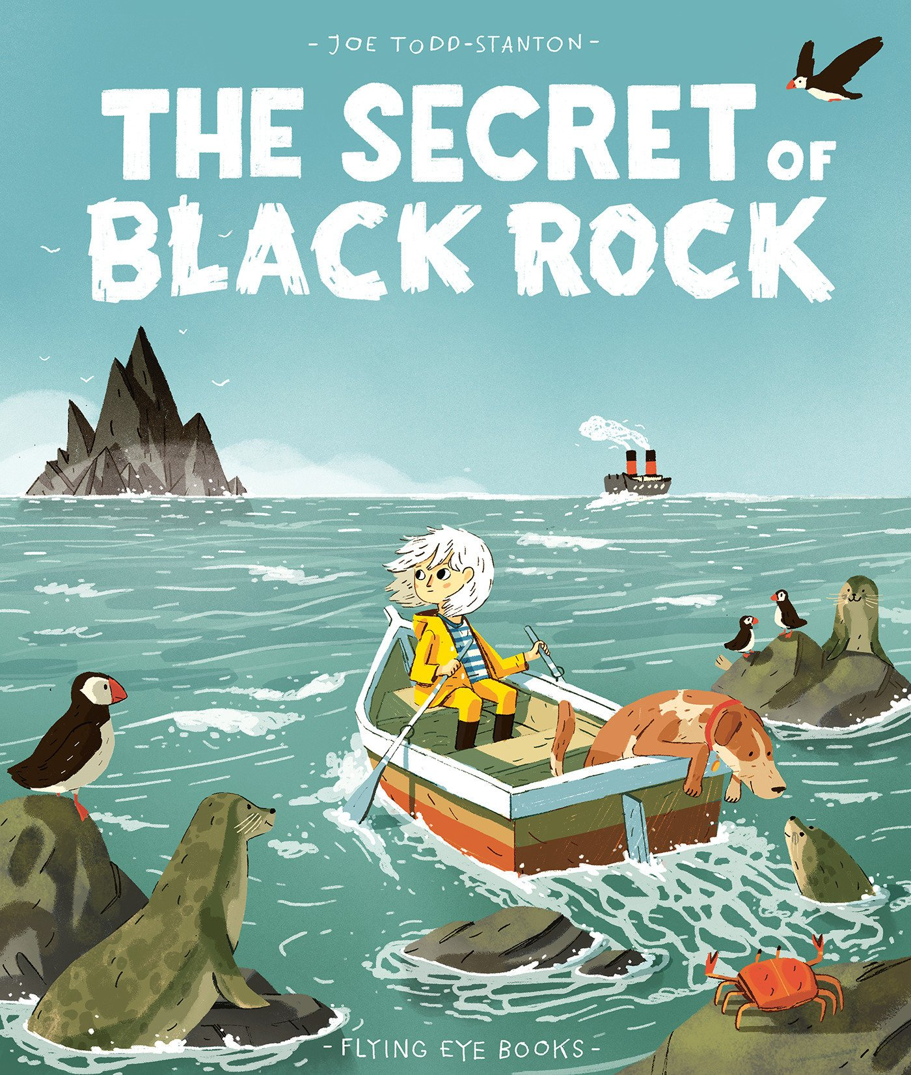 | 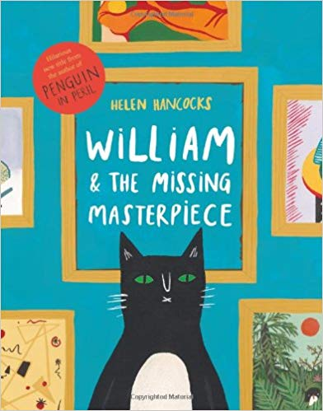
ENGLISH UNITS | Nat Fantastic  by Giles Andreae  Adventure story in familiar setting  Non chronological report  Class Read  The Hodgeheg  (Dick King Smith)  Short Novel |  | Into the Forest  by Anthony Browne  Traditional Tale  Instructions  Class Read  The Proudest Blue and other picture books  Diversity |  | The Diabolical Mr Tiddles  by Tom McLaughlin  Narrative (PSHE focus)  Newspaper Report  Class Read  The Diary of a Killer Cat  (Anne Frank)  Short Novel | Bee  by Charlotte Voake  Narrative (Topic)  Persuasive advert/poster  Spring Poems  Class Read  The Iron Man  (Ted Hughes)  Short Novel |  |  | The Secret of the Black Rock  by Joe Todd-Stanton  Narrative – Fantasy  Non chronological report  Class Read  Interview with a Shark  (Andy Seed)  Non-Fiction | William and the missing masterpiece  by Helen Hancocks  Narrative – Mystery  Recount – Diary entry  Class Read  Class choice
MATHS
Maths | Number Unit 1  Number and Place Value within 1,000  (11 lessons)  Number Unit 2  Addition and subtraction 1  (10 lessons) |  | Number Unit 3  Addition and subtraction 2  (9 days)  Number Unit 4  Multiplication and division 1  (15 lessons) |  | Number Unit 5  Multiplication and division 2  (14 lessons)  Measurement Unit 6  Money  (5 lessons)  Statistics Unit 7  Statistics  (5 lessons) | Measurement Unit 8  Length  (11 lessons)  Number Unit 9  Fractions 1  (11 lessons) |  |  | Number Unit 10  Fractions 2  (9 lessons)  Measurement Unit 11  Time  (11 lessons) | Geometry Unit 12  Angles and properties of shapes  (9 lessons)  Measurement Unit 13  Mass  (6 lessons)
RE
RE | Creation & Covenant |  | Prophecy & Promise |  | Galilee to Jerusalem | Desert to Garden |  |  | Ends of the Earth | Dialogue & Encounter
Science
Science | Light –  to see things, light reflected, sun dangerous, shadows |  | Animals including humans –  Nutrition, skeletons and muscles |  | Forces and magnets – Friction, magnetic forces, attract or repel | Forces and magnets – Friction, magnetic forces, attract or repel  Plants |  |  | Plants  Rocks, fossils and soil | Rocks, fossils and soil
Computing
Computing | Online Safety  Networks and the internet |  | Programming: Scratch |  | Emailing | Journey inside a computer |  |  | Video trailers using iPads | Comparison cards databases
History
History | Stone Age to Iron Age |  | Stone Age to Iron Age |  | Ancient Egypt including ancient civilisations | Ancient Egypt including ancient civilisation |  |  | Ancient Greece | Ancient Greece
Geography
Geography | Are all settlements the same? |  | Are all settlements the same? |  | Why do people live near volcanoes? | Why do people live near volcanoes? |  |  | Who lives in Antarctica? | Who lives in Antarctica?
Art and Design
Art | Drawing: Growing artists |  | Drawing: Growing artists |  | Painting and mixing media: Prehistoric painting | Painting and mixing media: Prehistoric painting |  |  | Craft and Design: Ancient Egyptian Scrolls | Craft and Design: Ancient Egyptian Scrolls
Design and Technology
DT | Food: Eating seasonally |  | Food: Eating seasonally |  | Structures: Constructing a castle | Structures: Constructing a castle |  |  | Mechanical systems: Pneumatic toys | Mechanical systems: Pneumatic toys
Music
Music | Developing singing technique (Theme: the Vikings) |  | Pentatonic melodies and composition (Theme: Chinese New Year) |  | Ballads | Jazz |  |  | Creating compositions in response to an animation (Theme: Mountains) | Traditional instruments and improvisation (Theme: India)
PE
PE | Football  Dance |  | Netball  Strength and Flexibility |  | Hockey  Dodgeball | Tri golf  Gymnastics – movement |  |  | Athletics/Badminton  Swimming | Rounders/Circuits(H&F)  Swimming
MFL
MFL | Basic questions about themselves |  | Classroom items |  | Identify the gender of a noun | Bilingual dictionaries  Family  Pets |  |  | Plural of nouns  Numbers to 39  Sentences with il y a | Months  Dates  Birthdays
PSHE
PSHE | Get up!  The Sacraments |  | Jesus, my friend  Friends, family and others |  | When things feel bad  Sharing online | Chatting online  Safe in my body |  |  | Drugs, alcohol and tobacco  First aid heroes | A community in love  What is church?  How do I love others?

