Homework 14.2.25

Dear Parents,

For homework and to support our RE topic, we would like the children to make a Lent cross. They are usually wood effect (or wooden coloured) to reflect the cross that Jesus died on, and may have purple cloth across. Shown are a couple of examples. The cross can be made from cardboard, wood, paper, or any material of your choice.

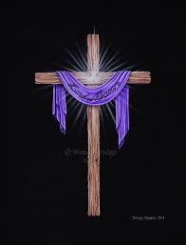 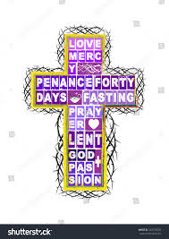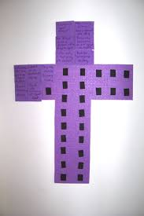

Please bring your cross into school by Wednesday March 5th.

Please read at least four times a week, sign the reading diary and return to school on a Friday.

Please also ensure reading books and diaries are returned on a Monday as well as the Friday, so that we can allocate new books, homework books are returned to school by Wednesday each week.

Thank you for all your support.

Miss Cook and Mrs Davies.