Y3 Homework – Friday 25th April

**English**

Our trip to Trentham Gardens was excellent and the children had a great time.

Write a recount of your favourite part of our trip, you should aim for about 3-5 sentences. Make sure you include detail including adjectives and conjunctions like because/but/although/while/after/until.

Don’t forget your basics (full stops/capital letters and joined up handwriting.

**Maths**

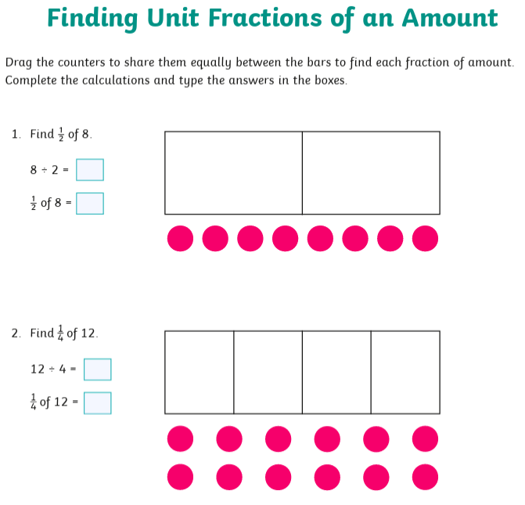Continue to practice your 1x, 2x, 3x, 4, 5x, 8x, 10x tables on hit the button and Timetable rockstars

