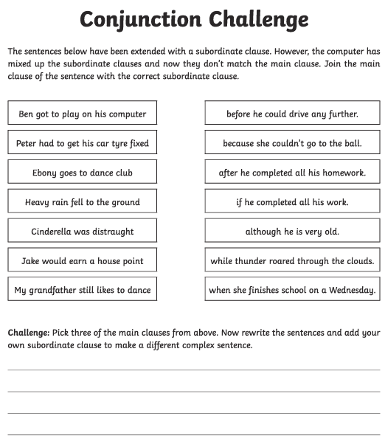**English**

**Maths**

Continue to practice your 1x, 2x, 3x, 4, 5x, 8x, 10x tables on hit the button and Timetable rockstar

Practising addition:

