**English / Science**

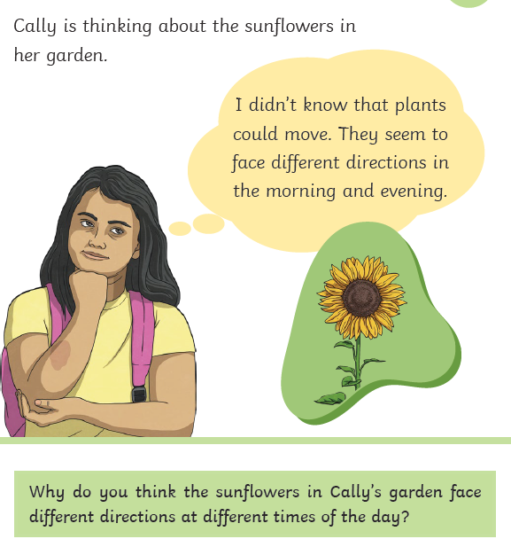

Notice flowers in your gardens or at the park, which way are they facing. Does it stay the same?

Challenge:

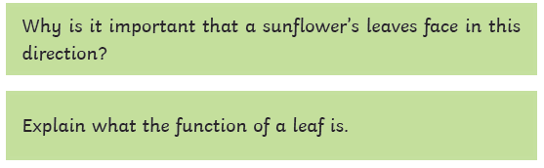

**Maths**

Continue to practice your 1x, 2x, 3x, 4, 5x, 8x, 10x tables on hit the button and Timetable rockstar

Watch the video and read the article about column subtraction: <https://www.bbc.co.uk/bitesize/articles/zc78srd#znkfwsg>

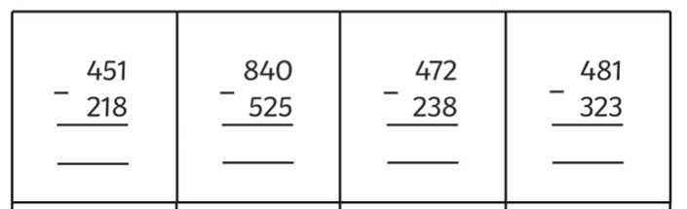Subtraction practice with option challenge: 