**English/Geography**

We have been learning about the physical and human features of Antarctica. Use the websites below to research and create an informative poster about Antarctica.

<https://www.bbc.co.uk/bitesize/articles/z4whsk7#z4jpf82>

<https://kids.britannica.com/kids/article/Antarctica/352760>

**Maths**

Continue to practice your 1x, 2x, 3x, 4, 5x, 8x, 10x tables on hit the button and Timetable rockstar

We have been learning about mass.

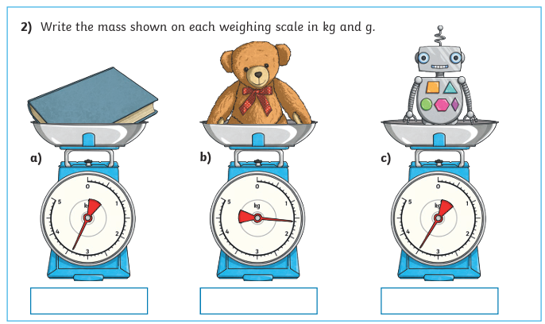

Challenge: Use your scales to find the mass of different objects around your home. Record your results in a table using kg and g.

Which object had the greatest mass?

Which object had the smallest mass?

