**Next Friday the children will be making pneumatic toys as part of their DT work. Please begin to bring in resources including: toilet rolls, bottles, egg cartons, tissue boxes, shoe boxes, cotton wool, socks, other recyclable materials**

**English/History**

In history we looked at why the Roman army was so successful. Carry out some research and design your own Roman soldier.

<https://www.bbc.co.uk/bitesize/articles/z7hhtrd#zc3yvwx>

<https://www.youtube.com/watch?v=OToh53wFh6c>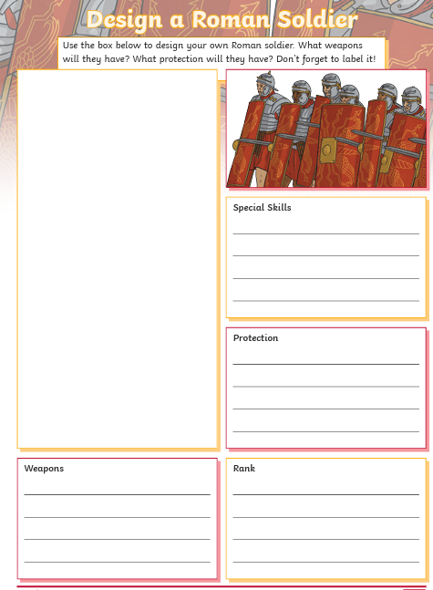

**Maths**

Continue to practice your 1x, 2x, 3x, 4, 5x, 8x, 10x tables on hit the button and Timetable rockstar

<https://www.youtube.com/watch?v=QlCCbZJYP1s>

Video of how to complete column subtraction with exchanging/renaming

