**English/Geography**

In Geography we learnt about Shackleton’s expedition to Antarctica on The Endurance. Create an informative poster detailing the expedition, you could include: the journey, what happened to The Endurance, what the men had to go through to stay alive (use knowledge of Antarctica to help). Use this website to help:

<https://kids.nationalgeographic.com/history/article/rediscovering-the-lost-endurance>

You may want to carry out your own research.

**Maths**

Continue to practice your 1x, 2x, 3x, 4, 5x, 8x, 10x tables on hit the button and Timetable rockstar

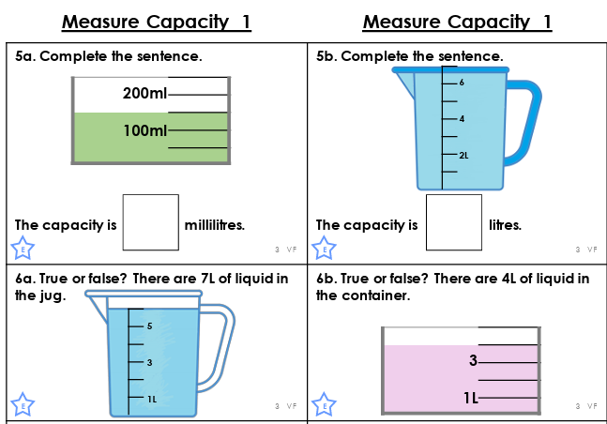

Explore capacity with jugs and bottled at your house, compare them. Predict which will hold the most/least and ue a measuring jug to find out if your predictions were correct.



5a. 150ml