First Concerns

Where a child appears to be behind expected levels or where a child’s progress gives cause for concern, practitioners should consider all the information about the child’s learning and development (SEN and disability code of practice). All the information should be brought together and considered with the child’s parents/carers.
SEN and disability in the early years: A toolkit

In this section you will find -
- Assess, Plan, Do and Review – guidance notes
- My plan
- My diary

Assess, Plan, Do and Review
Guidance Notes

Assess
Use
- My assessments and observations
- The Early Years Outcomes
- Advice from health colleagues eg Speech and Language Therapy Care Plans
- Advice from the Early Years and Childcare team

Plan
- What are my targets?
- What interventions and strategies will you put in place?
- How often will I do this?
- Do you need to make any alterations to my environment?
- Do you need to find any additional resources?
- Do you need to make any changes to my routine?

Do
- What activities will I do?
- Where will I do it?
- Who will do it with me?
- How often?

Review
- What have I learnt
- Did I achieve the planned steps?
- Did I achieve more than you planned?
- What helped me?
- What things went well?
- What are my next steps?
- What progress did I make?
- Where there any challenges?

My Plan

Name –
Age –
Key worker –
Date -

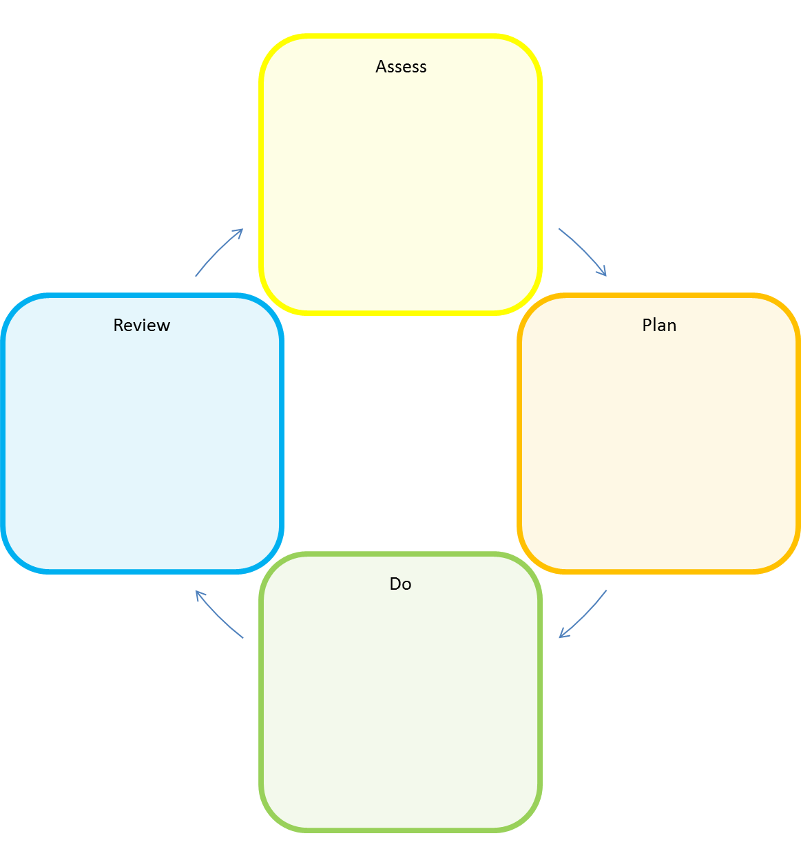

My Diary
Meetings, telephone conversations, review dates, Early Years and Childcare / other professionals visits

Date | What happened? | Comment / Actions
 | Discussion with my parents / cares

