Reception Autumn 1 Autumn 2 Spring 1 Spring 2 Summer 1 Summer 2
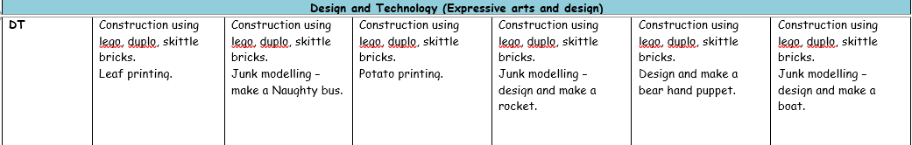
Year 1
Year 2

Year 3
Year 4
Year 5

Year 6

