Design & Technology

Curriculum Aims

At St. Mary’s, we are a proud Catholic school, with Christ at the heart of everything we do. We believe that every child is a gift from God, created in his own image and likeness. Our Mission Statement affirms that our aim is that every child reaches their full potential.
Pupils’ learning and development is at the centre of our school’s curriculum; it is broad, balanced and challenging, ensuring pupils develop the skills necessary to succeed in life after primary school. Our welcoming and nurturing environment, based on the Gospel Values, also allows every individual to develop their spiritual, moral, social and cultural growth.
We recognise that our children are the leaders of tomorrow and that we must prepare them to play an active and responsible role in society.

D&T Mission Statement.
At St. Mary’s our pupils will have the opportunity to gain skills and knowledge though designing, making and evaluating products.
We believe that design and technology will help to prepare children for the developing world and encourages them to become curious and creative problem-solvers. This will enable them to develop a critical understanding of its impact on daily life and the wider world.

INTENT
Why do we teach what we teach?
St Mary’s aim is to fulfil the requirements of the National Curriculum for design and technology and provide a broad and balanced curriculum which is fully inclusive of every child. We plan to ensure the progressive development of knowledge and skills, to allow our children to learn how to take risks, become innovative, resourceful, enterprising and capable citizens through evaluation of past and present design and technology, develop a critical understanding of its impact on daily life and the wider world, and to participate successfully in an increasingly technological world using the language of design and technology.
The aims of our teaching of design and technology are to: -
- Develop creative, technical and imaginative thinking.
- Develop confidence to participate successfully in an increasingly technological world.
- Enable children to talk about how things work and to develop their technical knowledge.
- Apply a growing body of knowledge, understanding and skills in order to design and make prototypes and products for a wide range of users.
- Encourage children to select appropriate tools and techniques when making a product, whilst following safe procedures.
- Develop an understanding of technological processes and products, their manufacture and their contribution to our society.
- Promote enjoyment, satisfaction and purpose in designing and making things.
- Analyse, evaluate and test their ideas and products, and the work of others.
- Understand and apply the principles of nutrition and to learn cooking techniques.
- Understand how key events and individuals in design and technology have helped shape the world.

IMPLEMENTATION
How do we teach what we teach?
St. Mary’s has implemented a curriculum that is progressive across the whole school to ensure the teaching and learning in design and technology is of a high standard. The teaching is focussed on knowledge and skills as stated in the National Curriculum. Our long-term plan for KS1 and KS2 follows Kapow, which offers engaging and progressive schemes of work to enrich learning and inspire pupils. This scheme also provides opportunities for practitioners to take part in new learning to allow for Outstanding teaching in every lesson We use ‘Kapow’ to deliver our lessons along with other resources which complement the teaching sequences. We ensure that design and technology is given the same importance as the core subjects, as we feel this is important in enabling all children to gain ‘real-life’ experiences.
A variety of teaching approaches are used when teaching design and technology, teachers should follow the pupil’s interests to ensure their learning is engaging, broad and balanced. Children excelling in design and technology will be recognised and acknowledged. Opportunities will be given for pupils work to be exhibited and celebrated through displays and celebration assemblies.
At St Mary’s Primary School, we provide a variety of opportunities for design and technology learning to take place inside and outside the classroom. Examples include: -
- After-school clubs such as the Lego Club and Cookery Club.
- Residential trips.
- Creative homework projects.
- Visits from local businesses.
- Creative learning opportunities such as Wellbeing Week, Science Week and other specific days.

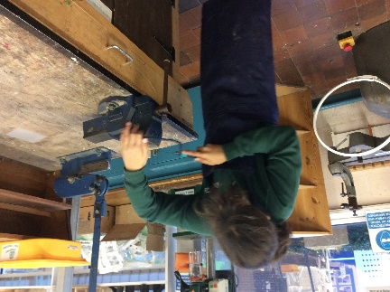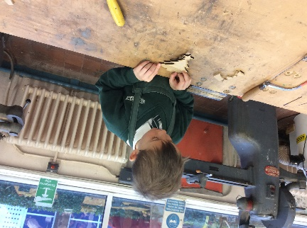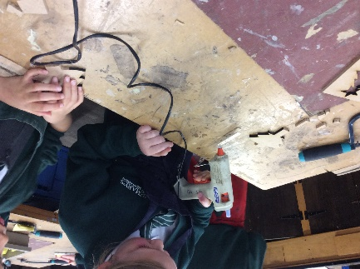
Educational visits are another opportunity for the teachers to plan for additional design and technology learning outside the classroom.
The children have opportunities throughout their learning journeys to visit local museums, food establishments and have visitors into school to share learning with hands on experiences. In recent years, teachers have linked with local high schools to use their facilities, technology and expertise. At St Mary’s Primary School, teachers make use of the extensive grounds and outdoor learning area when planning tasks.
EYFS
The EYFS framework is structured differently to the National Curriculum as it is organised across seven areas of learning rather than subject areas. The most relevant Early Years outcomes for DT are taken from the following areas of learning: -
- Physical Development
- Understanding the World
- Expressive Arts and Design
Children will begin to develop their moving and handling skills by learning to use tools, materials and objects effectively, including showing interest in making toys work by using objects, pulleys and knobs. They will begin to practise self-care by learning to understand the need for safety when tackling new challenges and using new equipment. Children will have the opportunity to explore their environment both in and outside the classroom, by observing and experimenting with mixing colours and textures, shaping and assembling new materials and using their imagination to help give a purpose to the constructions they may create. The Early Years Framework is where a child begins to gain a wider experience of the world around them. Each term has a broad ‘umbrella’ topic and the children’s interests are explored to shape the direction of the topic. Design and Technology skills are explored to create and construct linked to the topic. EG. Making a bus and constructing a town, linked to the Naughty Bus story as part of the Autumn topic ‘Stories and Me’
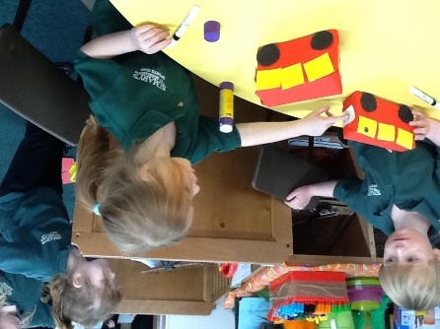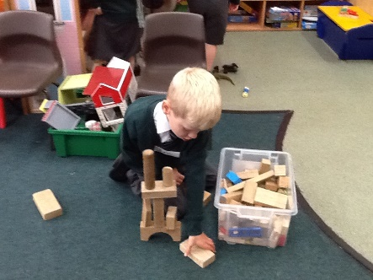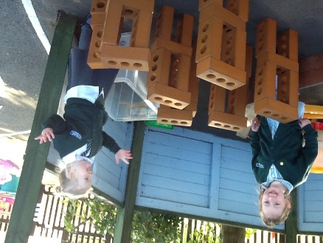
Designing and making a rocket as part of our ‘Space’ topic: -
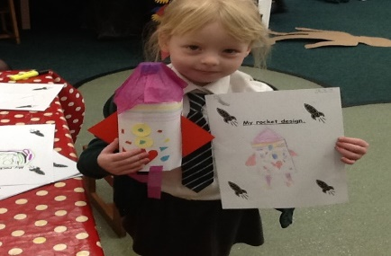
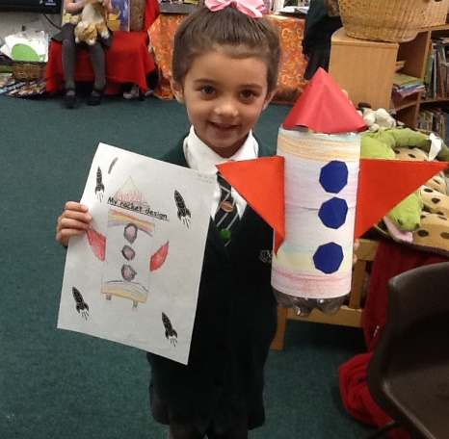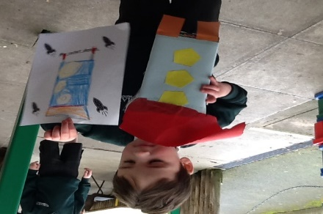

INCLUSION
St Mary's Catholic Primary School is an inclusive school, which supports and encourages all children to achieve. We are committed to high quality teaching and learning opportunities with Quality First Teaching at the core of curriculum planning. Pupils with special education needs (including gifted and talented children) receive support where appropriate, including differentiated work and small group support from TA's.

IMPACT
How do we measure what we teach?

At St. Mary’s we strive to deliver a design and technology curriculum of a high quality that has been planned to demonstrate progression of knowledge, skills and vocabulary. Our aim is to encourage pupils to combine practical skills with an understand of aesthetic, social and environmental issues along with functions and industrial practices. They are given the opportunities to reflect on past and present design and technology and evaluate them. Through our carefully planned sequence of lessons, we endeavour to promote children to become creative problem-solvers who are equipped to take part in the development of tomorrow’s rapidly changing world both as individuals and as part of a team.

We measure the impact of our curriculum through the following methods: -

- Assessing pupil’s understanding of topic linked vocabulary before and after the unit is taught.
- Retrieval practice opportunities such as mini quizzes.
- Summative assessment of pupil discussions about their learning.
- Images and videos of the pupil’s practical learning.
- Interviewing the pupils about their learning (pupil voice).
- Displays.

Reviewed October 2022

